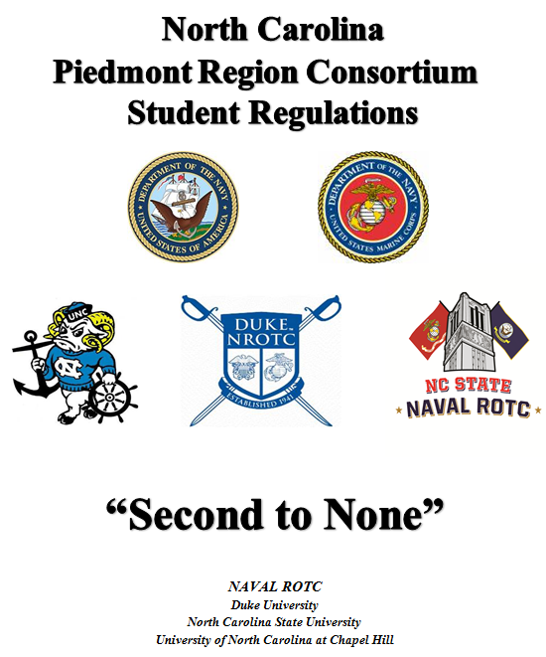

DEPARTMENT OF THE NAVY
NAVAL RESERVE OFFICERS TRAINING CORPS UNIT
NORTH CAROLINA PIEDMONT REGION
BOX 90456
DURHAM, NORTH CAROLINA 27708-0456

NROTCNCPRINST 5400.1D
30D

NROTC NORTH CAROLINA PIEDMONT REGION INSTRUCTION 5400.1D

From: Commanding Officer, NROTC Unit, North Carolina Piedmont
Region

Subj: STUDENT REGULATIONS

Ref: (a) NSTC M-1533.2; NROTC Regulations of Officer Development

Encl: Student Regulations
1. Purpose. To prescribe Student Regulations for the NROTC Unit, North Carolina Piedmont Region (NCPR) Consortium. This instruction has been revised and should be read in its entirety.

2. Cancellation. NROTCNCPRINST 5400.1C, North Carolina Piedmont Region Midshipman Regulations.

3. Background. These regulations are promulgated in order to (1) provide instruction and information for the performance of student duties, and (2) govern operations and activities of the students assigned to the NCPR Battalions of Duke University, North Carolina State University (NCSU), and the University of North Carolina at Chapel Hill (UNC). Unless specifically indicated, the term "students," as it appears in these regulations, shall be interpreted to include all Scholarship, College Program, Navy Officer Candidates (OC), and Marine Enlisted Commissioning Education Program (MECEP) students.

4. Action. A copy of the regulations will be made available to all NCPR students electronically. All staff and students are to become thoroughly familiar with these regulations. The student chain of command is responsible for maintaining an up to date hard copy manual in serviceable condition, in each Battalion's wardroom.

S. M. GILLESPIE

Distribution: NROTCNCPRINST 5216.1
List I

NCPRC STUDENT REGULATIONS

TABLE OF CONTENTS PAGE

I. MISSION, CO’s INTENT, LEADERSHIP ARC, AND HONOR CODE...........4

II. OATHS OF OFFICE................................................6

III. BATTALION STRUCTURE AND BILLET DESCRIPTIONS....................7

IV. MILITARY CUSTOMS AND COURTESIES...............................20

V. ACADEMIC EXCELLENCE...........................................23

VI. PROFESSIONAL DEVELOPMENT......................................25

VII. PHYSICAL TRAINING.............................................33

VIII. SUMMER TRAINING ............................................. 36

IX. UNIFORM GUIDANCE AND GROOMING STANDARDS.......................38

X. AWARDS........................................................46

APPENDICES

A. MILITARY CHAIN OF COMMAND.......................................50

B. PHYSICAL FITNESS STANDARDS......................................52

C. US NAVY UNIFORM REGULATIONS (NAVPERS 15665I, ARTICLE 6101)......60

D. LAB RATING FORM.................................................70

E. STUDENT EVALUATION FORMAT (NAVPERS 1610/2)......................71

F. PLAN OF THE WEEK TEMPLATE.......................................73

G. TURNOVER CHECKLIST..............................................74

H. STRIPER REQUEST TEMPLATE........................................75

I. EXAMPLE COMBINED STAFF BATTLE RHYTHM............................77

J. EXAMPLE PLAN OF ACTION AND MILESTONES (POA&M)...................78

K. LETTER OF INSTRUCTION TEMPLATE..................................79

L. SPECIAL REQUEST/AUTHORIZATION FORM (NAVPERS 1336/3).............83

NSTCINST 5000.1 (included) PAGE

I. NSTCINST 5000; COMMAND POLICY STATEMENTS

- EQUAL OPPORTUNITY........................................84
- SEXUAL HARRASMENT........................................85
- HAZING...................................................86
- SEXUAL ASSAULT ..........................................87
- SAFETY...................................................88

NORTH CAROLINA PIEDMONT CONSORTIUM POLICIES (NOT included)

I. URINALYSIS TESTING PROGRAM

II. ELECTIVE PHOTOREFRACTIVE KERATECTOMY SURGERY POLICY

III. STUDENT EVALUATIONS

IV. GOOD ORDER AND DISCIPLINE

V. NROTC NCPR FITNESS ENHANCEMENT PROGRAM (FEP) GUIDANCE

CHAPTER I
NROTC MISSION AND HONOR CODE

Article
101. Mission, CO’s Intent, Leadership Arc
102. Honor Code

101. MISSION, VISION AND TOP FIVE PRIORITIES

1. The NROTC Program was established to develop midshipmen mentally, morally and physically and to imbue them with the highest ideals of duty, and loyalty, with the core values of honor, courage and commitment in order to commission college graduates as naval officers who possess a basic professional background, are motivated toward careers in the naval service, and have a potential for future development in mind and character so as to assume the highest responsibilities of command, citizenship and government.

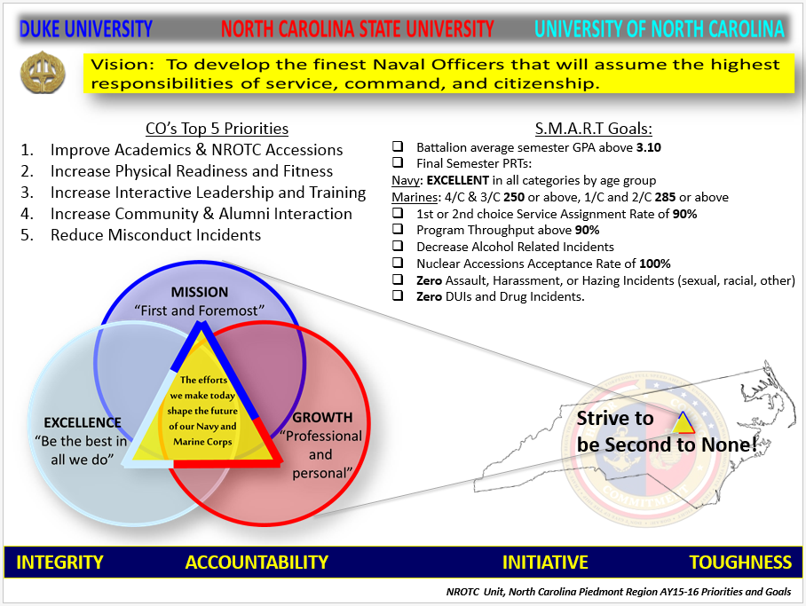
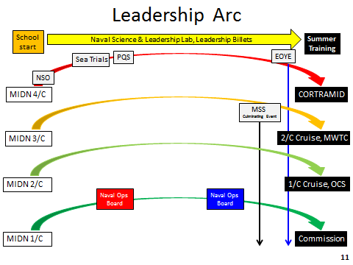

102. HONOR CODE

Midshipmen, Sailors, and Marines do not lie, cheat, or steal.

"Midshipmen [sailors and Marines] are persons of integrity: They stand for that which is right. They tell the truth and ensure that the full truth is known.
They do not lie.

They embrace fairness in all actions. They ensure that work submitted as their own is their own, and that assistance received from any source is authorized and properly documented.
They do not cheat.

They respect the property of others and ensure that others are able to benefit from the use of their own property.
They do not steal."

CHAPTER II
OATHS OF OFFICE

Article
201. Oath of Office for Scholarship Midshipmen
202. Oath of Office for College Program Students
203. Oath of Office for Enlisted Active Duty Students
204. Oath of Office for Officers

201. OATH OF OFFICE FOR SCHOLARSHIP MIDSHIPMEN

I (state your name), having been appointed a Midshipman in the United States Navy, do solemnly swear (or affirm) that I will support and defend the Constitution of the United States against all enemies, foreign and domestic; that I will bear true faith and allegiance to the same; that I take this obligation freely, without any mental reservation or purpose of evasion; and that I will well and faithfully discharge the duties of the office on which I am about to enter; so help me God*.

202. OATH OF OFFICE FOR COLLEGE PROGRAM STUDENTS
I (state your name), swear (or affirm) that I will support and defend the Constitution of the United States against all enemies, foreign and domestic; that I will bear true faith and allegiance to the same; and that I take this obligation freely, without any mental reservation or purpose of evasion; so help me God*.

203. OATH OF OFFICE FOR ENLISTED ACTIVE DUTY STUDENTS

I (state your name), do solemnly swear (or affirm) that I will support and defend the Constitution of the United States against all enemies, foreign and domestic; that I will bear true faith and allegiance to the same; that I will obey the orders of the President of the United States and the orders of the officers appointed over me, according to regulations and the Uniform Code of Military Justice; so help me God*.

204. OATH OF OFFICE FOR OFFICERS

I (state your name), do solemnly swear (or affirm) that I will support and defend the Constitution of the United States against all enemies, foreign and domestic; that I will bear true faith and allegiance to the same; that I take this obligation freely, without any mental reservation or purpose of evasion; and that I will well and faithfully discharge the duties of the office on which I am about to enter; so help me God*.

*“So help me God” may be omitted.

CHAPTER III
BATTALION STRUCTURE AND BILLET DESCRIPTIONS

Article
301. General Purpose and Responsibility
302. Battalion Organization
303. Billet Descriptions and Responsibilities

301. GENERAL PURPOSE AND RESPONSIBILITY
1. Purpose. The student command and staff are responsible for the administration, proper functioning, and the continual improvement of their Battalion. The active duty staff provides oversight and mentorship to the student billet holders and enhances each student’s overall leadership experience. Student officers and student non-commissioned officers are expected to uphold the highest levels of military decorum and discipline, physical fitness, personal honor, and academic excellence to serve as an example for their subordinates.

2. Responsibility. Student officers and student non-commissioned officers are assigned appropriate authority and responsibility for the direction and administration of the Battalion. In the performance of their duties, these students assume the accountability of command, especially in the maintenance of discipline and in the direction of evolutions. Senior billet holders may delegate their assigned authority to their juniors, but, as is the case at all levels of command, they cannot delegate their overall accountability. Other duties applicable to all students in positions of special trust, authority, and responsibility include the following:
a. Knowing their specific assignments and responsibilities as outlined in this chapter, maintaining a turnover binder, and conducting a thorough turnover of their duties properly with their respective replacements.

b. Knowing those under their command and contributing to their personal, military, and academic success (i.e. having a professional relationship that affects their subordinate on a personal level).

c. Anticipating requirements, taking the initiative, and issuing appropriate and timely orders, according to their authority, to those under their command and ensuring that those orders are executed as intended.

d. Maintaining discipline in their unit and directing all evolutions under their charge.

e. Fostering good communication both up and down the chain-of-command.

f. Having detailed knowledge of this instruction and ensuring that all those under their command adhere to these regulations.

g. Observing attention to detail in the performance of those under their command and taking every opportunity to recognize outstanding performance or to correct deficient performance as it occurs.

h. Assessing the capabilities and shortfalls of their unit and making improvements to their team and the individuals in their unit.

302. BATTALION ORGANIZATION

1. General. The student Battalion organization will be divided into two striper sets: fall and spring. The Battalion Advisor oversees the organization and command of the Battalion. All students (except MIDN Lieutenant and above, the Battalion Sergeant Major, Company First Sergeants, and Platoon Commanders/Sergeants) will be assigned to a Squad/Division for muster and drill purposes.

2. Precedence. Student officers and student non-commissioned officers will assume the rank and responsibilities assigned to them per this instruction. The leadership and experience that active duty students bring to the Battalion cannot be overstated; however, their direct authority is limited to the scope of the billets to which they are appointed in the Battalion. For students of the same rank, or for students with no assigned rank, the following specific precedence shall be observed amongst members of the Battalion:

a. Precedence among students of different classes is in the order of academic designation (seniors, juniors, sophomores, freshmen). Midshipmen will normally advance to their next class rank (1/C, 2/C, 3/C) following the completion of the spring semester commissioning ceremony or as directed by the Battalion Advisor. Officer Candidates and MECEP students, as active duty military members, associate with the Midshipman class of the same graduating class year.

b. Precedence among midshipmen of the same class is defined first in accordance with their rank as midshipmen officers or non-commissioned officers, as applicable, and then by NROTC class standing.

c. In the absence of a student regularly or specifically detailed to take charge of a unit, responsibility for commanding the unit will fall to the senior student present.

3. Battalion Size. The overall structure and number of billet holders in each NCPR student Battalion will be determined by the number of students in the Battalion.

a. As a general rule:

(1) Squads/Divisions will contain no less than four and no more than thirteen students.

(2) Platoons/Departments will contain no less than two Squads/Divisions, no more than four Squads/Divisions, and no more than forty students.

(3) Companies, if utilized, will contain no less than two Platoons, no more than three Platoons, and no more than ninety students. Note: There is no equivalent to a Company when utilizing the Department structure.

b. With the fluctuation of Battalion structures, the student Battalion staff and Battalion Advisor should ensure that all billet holders are “gainfully employed.”

4. Battalion Structure. Billet titles, rank, and quantity are provided for each university in the tables listed below. Precedence of billets is in the order listed. Among those student officers or student non-commissioned officers holding the same billet, precedence is determined by aptitude class standing.
University of North Carolina at Chapel Hill TARHEEL Battalion

MIDN RANK | OFFICER/NCO BILLET TITLE | STUDENT | NO.
CDR/LtCol | Battalion Commander | 1/2/O/M | 1
LCDR/Maj | Battalion Executive Officer | 1/2/O/M | 1
LT/Capt | Battalion Operations Officer | 1/2/O/M | 1
LTJG/1stLt | Battalion Administrative Officer/Adjutant | 1/2/O/M | 1
LTJG/1stLt | Platoon Commander | 1/2 | 2
LTJG/1stLt | Logistics Officer | 1/2/O/M | 1
LTJG/1stLt | Semper Fi President/Operations Officer | 1/2/M | 1
ENS/2ndLt | Physical Training Officer | 1/2 | 1
ENS/2ndLt | Training Officer | 1/2/O/M | 1
MCPO/SgtMaj | Battalion Sergeant Major | 1/2 | 1
CPO/GySgt | Drill Team & Color Guard Chief | All | 1
CPO/GySgt | Academics Chief | 2/3 | 1
CPO/GySgt | Community Service Chief | All | 1
PO2/Sgt | Squad Leader | 2/3 | 4
PO2/Sgt | Alumni Affairs Editor | All | 1
PO3/Cpl | Webmaster/Historian/Photographer | All | 1
PO3/Cpl | Morale, Welfare, & Wellness Coordinator | All | 1

Duke University BLUE DEVIL Battalion

MIDN RANK | OFFICER/NCO BILLET TITLE | STUDENT | NO.
CDR/LtCol | Battalion Commanding Officer | 1/2/O/M | 1
LCDR/Maj | Battalion Executive Officer | 1/2/O/M | 1
LT/Capt | Operations Department Head | 1/2/O/M | 1
LT/Capt | Administration Department Head | 1/2/O/M | 1
LTJG/1stLt | Future Operations Officer | 1/2/O/M | 1
LTJG/1stLt | Public Affairs Division Officer | 1/2/O/M | 1
LTJG/1stLt | Academics Division Officer | 1/2/O/M | 1
LTJG/1stLt | Logistics Division Officer | 1/2/O/M | 1
LTJG/1stLt | Athletics Division Officer | 1/2/O/M | 1
MCPO/SgtMaj | Command Master Chief | 1/2 | 1
SCPO/MSgt | Administrative Leading Chief Petty Officer | 1/2/3 | 1
SCPO/MSgt | Training Leading Chief Petty Officer | 1/2/3 | 1
SCPO/MSgt | Logistics Leading Chief Petty Officer | 1/2/3 | 1
SCPO/MSgt | Athletics Leading Chief Petty Officer | 1/2/3 | 1
CPO/GySgt | Community Service Petty Officer | All | 1
CPO/GySgt | Recruitment/Historian Petty Officer | All | 1
CPO/GySgt | Training Petty Officer | All | 1
CPO/GySgt | Morale, Welfare, & Recreation Petty Officer | All | 1

North Carolina State University WOLFPACK Battalion

MIDN RANK | OFFICER/NCO BILLET TITLE | STUDENT | NO.
CDR/LtCol | Battalion Commander | 1/O/M | 1
LCDR/Maj | Battalion Executive Officer | 1/O/M | 1
LCDR/Maj | Battalion Operations Officer | 1/O/M | 1
LT/Capt | Battalion Administrative Officer/Adjutant | 1/O/M | 1
LT/Capt | Battalion Academics Officer** | 1/O/M | 1
LT/Capt | Battalion Logistics Officer** | O | 1
LT/Capt | Company Commander | 1/O/M | 2
LT/Capt | Semper Fi President/Operations Officer | 1/2/M | 1
LTJG/1stLt | Battalion Assistant Operations Officer | 1/2/O | 1
LTJG/1stLt | Battalion Physical Training Officer | 1/2/O/M | 1
LTJG/1stLt | Platoon Commander | 1/2/O/M | 4
LTJG/1stLt | Supply Officer | 1/2/O/M | 1
ENS/2ndLt | Drill Team Commander | 1/2 | 1
ENS/2ndLt | Color Guard Commander | 1/2 | 1
ENS/2ndLt | Joint & Community Liaison Officer | 1/2/O/M | 1
ENS/2ndLt | Fitness Enhancement Program (FEP) OIC | 1/2/O/M | 1
MCPO/SgtMaj | Battalion Sergeant Major | 1 | 1
SCPO/1stSgt | Company First Sergeant | 1/2 | 2
SCPO/MSgt | Academics Chief | 2/3 | 2
SCPO/MSgt | End of Year Exercise Coordinator** | 1 | 1
CPO/GySgt | Logistics Chief | O | 1
CPO/GySgt | Supply Chief | 2/3 | 1
CPO/GySgt | Fitness Enhancement Program (FEP) Chief | 2/3 | 1
PO1/SSgt | Platoon Sergeant | 2/3 | 4
PO2/Sgt | Public Affairs & Alumni Engagement Petty Officer/Sergeant | 1/2/3 | 1
PO2/Sgt | Color Sergeant | 1/2/O/M | 1
PO2/Sgt | Squad Leader | 2/3/O | 12
PO2/Sgt | Battalion Guide | 2/3* | 1
PO3/Cpl | Company Guide | 3/4* | 2
PO3/Cpl | Fire Team Leader | 1/2/O/M | 24
PO3/Cpl | Historian/Photographer | 2/3/4 | 1
PO3/Cpl | Webmaster | All | 1
PO3/Cpl | Intramural Sports Petty Officer/Corporal | All | 1

1 = MIDN 1/C, 2 = MIDN 2/C, 3 = MIDN 3/C, 4 = MIDN 4/C;
O = Officer Candidate; M = MECEP
* = Top MIDN not assigned a billet for the semester
** = Year-long billet

5. Striper Selection Procedures. The Battalion Advisor recommends, and the Commanding Officer appoints, select student officers of the Battalion organization via the Battalion Striper Selection Process. Appointment of remaining officers and billets is delegated to the Battalion Commander and his or her staff subject to the approval of the Battalion Advisor and Commanding Officer. Leadership shall be inescapable. To the greatest extent possible, student officers shall be selected for each semester to maximize leadership opportunities for the largest number of students.

a. All volunteer and qualifying students will be provided information on Striper Selection Process procedures and documentation required well in advance of the scheduled selection process.

b. The Battalion Advisor will oversee the Battalion Striper Selection Process. Once selection forms are received, the Battalion Advisor will consult the active duty staff as necessary to determine recommendations for select billets (e.g. Battalion Commander). The active duty staff will nominate appropriate students to interview with the Commanding Officer and Executive Officer for these select billets. Once these billets are appointed, the newly appointed Battalion Commander will fill the remaining available billets with input from the Battalion Advisor, and any other active duty staff the Battalion Advisor requests for the selection process (generally all active duty staff).

c. In selecting nominees, the staff will consider students who set the example, maintain Battalion standards, and will best represent the Battalion as a whole. Academic, military, and physical performance will all be heavily considered but none will singularly disqualify a student from a billet. Student preparation and demonstrated commitment to the Battalion via submitted Striper Board Form will be most heavily weighted in the selection process.

d. The Battalion Advisor will notify all selected students of their billets after obtaining final approval from the Commanding Officer.

6. STA-21 and MECEP Students. Navy OC and Marine Corps MECEP students will be fully integrated into the Battalion’s organizational structure and maintain eligibility to serve in leadership billets within the unit. Given their experience in the operational Navy and Marine Corps, they are expected to actively seek responsibility within the Battalion and provide mentorship to Midshipmen in the performance of their duties, particularly if they are not current billet holders.

303. BILLET DESCRIPTIONS AND RESPONSIBILITIES

1. Battalion Staff

a. Battalion Commander. The senior student in the Battalion organization, he or she commands the Battalion. The Battalion Commander will execute the policies of the Commanding Officer, ensure mutual respect for all students, maintain the Battalion in the highest state of efficiency, be sensitive to the state of morale, be accountable for the conduct of the Battalion, keep the Battalion Advisor and Commanding Officer informed regarding any deficiencies, and recommend corrective action to be taken. The Battalion Commander will assign collateral duties to members of the Battalion staff and other designated students as required. Specific duties and responsibilities:

(1) Represents the Battalion at official unit functions, university functions, and to the broad university and local community.

(2) Plans and executes a professional semester training program that supports the mission of Naval ROTC and the goals and objectives of the Battalion Advisor and Commanding Officer.

(3) Represents the student chain of command at meetings with the Battalion Advisor, Commanding Officer, and when requested, at other unit staff meetings.

(4) Advises the Commanding Officer on issues pertaining to the good order and welfare of the Battalion.

(5) Uses the student chain of command to promulgate and enforce new directives. Ensures timely and effective communication both within the student chain of command and to the officer chain of command.

(6) Plans and carries out the weekly events of the Battalion in coordination with the chain of command.

b. Executive Officer. Second in command of the Battalion, and principal assistant and advisor to the Battalion Commander. The Executive Officer has the primary responsibility of overseeing the operation of the Battalion staff. Additional duties and responsibilities:

(1) Fulfills the duties of the Battalion Commander in his/her absence.

(2) Responsible for ensuring the proper image and good conduct of the Battalion.

(3) Delegates necessary administrative and operational tasks to the appropriate Battalion staff member or student in accordance with the responsibilities assigned to them per this instruction.

(4) Schedules and conducts Battalion staff meetings.

(5) Authorizes instructions pertaining to the use of Battalion spaces or property (e.g., wardroom, bulletin boards, mailboxes, storage, etc.) and maintains responsibility for their overall condition.

(6) Oversees and directs the student evaluation system and Battalion mentorship program.

c. Operations Officer. Responsible for the organization, planning, and execution of all operations involving the student Battalion. The Operations Officer reports directly to the Battalion Commander and fulfills the following specific duties and responsibilities:

(1) Executes the Battalion training plan, Plan-of-the-Week (POW), and lab schedule in coordination with the Battalion Advisor and provides timely updates to the Battalion staff on any schedule changes.

(2) Coordinates planning for Consortium and Tri-Service social and athletic events with his/her respective counterparts.

(3) Together with the Battalion Commander and Executive Officer, evaluates the success of all Battalion operations and evolutions and maintains files of all safety and after-action reports.

(4) Delegates specific tasks to the Assistant Operations Officer as needed to assist with planning for specific events.

d. Administrative Officer/Adjutant. Responsible to the Battalion Commander for performing the administrative functions of the Battalion. Specific duties and responsibilities:

(1) Maintains an accurate record of Battalion muster reports and continuously updates the master Battalion roster.

(2) Coordinates, updates, and publishes all general unit information (via the Battalion web page and/or newsletter) including the Battalion Organizational Chart, the chain of command, and the Battalion directory.

(3) Maintains all necessary Battalion files and reports and ensures all students’ personal information is appropriately safeguarded.

(4) Maintains and updates the Battalion copy of Student Regulations and ensures all related instructions and directives are available to students for reference.

(5) Submits required weekly reports and staff meeting minutes to the Executive Officer and Battalion Advisor.

(6) Responsible for quality assurance and timely completion of student evaluations in accordance with unit directives.

(7) Seeks nominations for and controls the awarding and issuance of student awards as detailed in Chapter X of this instruction.

e. Academics Officer/LCPO. Responsible for making academic assistance information available to students. Reports to the Battalion Commander and fulfills the following duties and responsibilities:

(1) Oversees and directs the mid-term academic evaluation system to identify and make recommendations regarding Midshipmen with academic deficiencies to the Battalion Advisor and appropriate officer class advisor.

(2) Oversees the Battalion study hall program ensuring that study hall locations and environments are safe, resourceful, and conducive to learning.

(3) Organizes and promotes the use of Battalion tutoring networks among Midshipmen.

(4) Maintains complete knowledge of available university academic resources and provides information to Midshipmen to assist them with their studies as required.

f. Logistics Officer. Responsible for managing Battalion logistical, financial, supply, and information technology (IT) functions. Reports to the Battalion Commander and fulfills the following duties and responsibilities:

(1) Manages Battalion financial accounts (Quarterdeck Society, Semper Fi Society, etc.) to include budgeting, controlling deposits and expenditures, and maintaining all required financial documentation.

(2) Coordinates with the staff supply technician to manage the supply and issuance of Midshipmen uniforms/insignia, student awards, and other required items or equipment.

(3) Procures, as necessary, special equipment and supplies for Battalion activities.

(4) Coordinates fundraising activities to include liaison with appropriate outside (university) personnel, staff and student attendance, and logistical support.

(5) Maintains and ensures cleanliness and organization of Battalion supply and storage spaces.

(6) Maintains Battalion IT hardware (computers, printers, etc.) to include resolving any hardware/software problems or deficiencies.

(7) Maintains updates and functionality of the Battalion website together with the Administrative Officer and Battalion webmaster.

g. Assistant Operations Officer. Responsible to the Operations Officer for the execution of the Battalion Training Plan and Midshipman 4/C Personnel Qualification Standards (PQS) training. Additional duties and responsibilities:

(1) Reserving university facilities (classrooms, athletic fields/facilities, etc.), as required, to support training evolutions.

(2) Assists the Operations Officer in the execution of large events such as official ceremonies, competitions, etc.

(3) Recruits volunteers, as needed, to help with the execution of other Battalion events and perform administrative tasks.

(4) Responsible for proposing changes to and editing the Battalion PQS manual. Coordinates the overall conduct of Fourth Class professional training.

(5) Performs such other duties as the Operations Officer may direct.

h. Physical Training Officer. Responsible to the Battalion Commander and Command Fitness Leader (CFL) for the administration and safety of all Battalion physical training. Duties and responsibilities:

(1) Prepares and submits to the CFL and Battalion Advisor a proposed schedule of Battalion athletic and physical training events for the semester in accordance with the Battalion Commander’s command vision.

(2) Coordinates and executes, with the CFL, both the Battalion inventory and official Physical Fitness Assessments (PFA) in accordance with applicable Navy and Marine Corps Instructions.

(3) Collects and reports results to the chain of command, as appropriate.

(4) Coordinates student participation in the Fitness Enhancement Program (FEP).

(5) Coordinates with the Operations Officer to plan and execute Battalion and Consortium field meets and tri-service athletic competitions, as applicable.

i. Sergeant Major/Command Master Chief. Reports directly to the Battalion Commander regarding the conduct, appearance, training, and performance of the Battalion. Specific duties and responsibilities:

(1) Forms the Battalion for physical training, laboratory, and drills and makes muster reports to the Battalion Commander.

(2) Maintains responsibility, together with the Executive Officer, for the proper conduct of the Battalion ensuring proper adherence to these Student Regulations and other Navy & Marine Corps Service customs and courtesies.

(3) Executes Extra Military Instruction (EMI) training, as required, and aids in the planning of morale and recreation events for the Battalion.

(4) Forwards recommendations to the Battalion Commander on issues concerning morale and the Battalion at large.

(5) Keeps the Battalion informed on policy changes, decisions, answers to their questions, and what is being done to address their concerns.

(6) If used, supervises Company First Sergeants and Platoon Sergeants in the performance of their duties, as applicable.

2. Company Staff

a. Company Commander. Responsible for the safety, well-being, and efficiency of the Company. The Company Commander executes the Battalion’s operational orders and reports to the Battalion Commander. Specific duties and responsibilities:

(1) Commands and oversees the training and proficiency of the Company in all matters.

(2) Maintains order and discipline within the Company.
(3) Maintains cognizance on all personal matters relating to members of the Company including, but not limited to, medical status, academics, military or physical training issues, and attendance at required events.

(4) Performs such duties and issues such orders as necessary to prepare the Company for all Battalion requirements including inspections, PFA's, etc.

(5) Attends Battalion staff meetings to report on Company status.

b. First Sergeant. Reports directly to the Company Commander regarding the conduct, appearance, training, and performance of the Company. Duties and responsibilities:

(1) Forms the Company for physical training, laboratory, and drills and makes muster reports to the Company Commander and Battalion Sergeant Major.

(2) Supports the Battalion Sergeant Major by ensuring proper Company adherence to Student Regulations and other Navy and Marine Corps service customs and courtesies.

(3) Makes frequent inspections of Company members and takes remedial action to correct discrepancies at the earliest possible opportunity.

(4) Together with the Platoon Sergeants, acts as a recorder for all inspections of the Company; reports discrepancies to the Company Commander for resolution.

3. Platoon/Department Staff

a. Platoon Commander/Department Head. The senior member of the Platoon/Department who aids the Company Commander (if used) in carrying out Company and Battalion operational orders and enforcing policy. Specific duties and responsibilities:

(1) Commands and supervises the work, training, and conduct of members of the Platoon/Department.

(2) Maintains standards of performance and conduct; evaluates and keeps a record of Platoon/Department member performance at drills, inspections, physical training, and other evolutions.

(3) Counsels and evaluates members of the Platoon/Department both as needed and as required.

(4) Makes recommendations to the Company Commander (Battalion Executive Officer) on matters concerning members of the Platoon (Department) - e.g. academic related, conduct related, special requests, etc.

(5) Coordinates with other Platoon Commander(s)/Department Head(s) to make thoughtful recommendations to the Company Commander/Battalion Executive Officer on matters of policy to ensure full coordination.

b. Platoon Sergeant. Assists the Platoon Commander in executing Platoon objectives. Platoon Sergeants are not applicable to Departments. Specific duties and responsibilities:

(1) Obtains accurate musters at each formation.

(2) Supports the Company First Sergeant and Battalion Sergeant Major by ensuring proper Company adherence to Student Regulations and other Navy and Marine Corps Service customs and courtesies.

(3) Forms the Platoon for drills and oversees Platoon physical training.

c. Squad Leader/Division Officer. Exercises authority and control over members of the Squad/Division. Squad Leaders/Division Officers are often considered to be the most integral part of the chain of command and thus should strive to set the example for the members of their Squad/Division to follow in all areas of performance. The Squad Leader/Division Officer reports directly to the Platoon Commander/Department Head and fulfills the following specific duties and responsibilities:

(1) Responsible to the Platoon Commander/Department Head for duties assigned to the Squad/Division and for the conduct, academic performance, and personal issues of Squad/Division members.

(2) Maintains accountability of Squad/Division members and seeks approval, when necessary, for Squad/Division members to be excused from physical training or other events.

(3) Maintains knowledge of the duty status, physical status, capabilities, and needs of each Squad/Division member and ensures good communication of the same up and down the chain of command.

(4) Ensures Squad/Division compliance with all regulations and policies of the Battalion and higher authority.

(5) Ensures Squad/Division members maintain high standards of uniform appearance through frequent inspections.

(6) Supervises Squad/Division training, particularly in the area of MIDN 4/C indoctrination and professional knowledge.

(7) Maintains a Squad Leader's/Division Officer’s notebook, identifying and documenting the performance of each Squad/divsion member.

(8) Initiates a fitness report/evaluation on each Squad/divsion member each semester.

d. Fireteam Leader (NCSU). Upperclassmen mentors who provide assistance and advice to their Squad leader and monitor the academic, physical, mental, and emotional status of their fireteam members. Their duties include:

(1) Assist their Squad leader in matters of accountability by being aware of their members’ commitments and personal issues.

(2) Assist their Squad leader in training the Squad's MIDN 4/C during the PQS process.

(3) Provide backup to the Squad leader to identify individuals of the Squad who may be struggling in academics, physical fitness, or personal life.

(4) Assist the Squad leader in his or her role as the primary small unit leader.

4. Other Student Billets. Students are nominated by the Battalion Staff, with the approval of the Battalion Advisor and Commanding Officer, to fill various billets and perform collateral duties as required at each university. Such billets and duties may include (but are not limited to): public affairs officer/chief, webmaster, photographer, Dining-In coordinator, etc. Specific duties related to each of these billets are dictated by individual Battalions.

CHAPTER IV
MILITARY CUSTOMS AND COURTESIES

Article
401. Saluting and Greeting Senior Military Members
402. Chain of Command
403. Official Correspondence

401. SALUTING AND GREETING SENIOR MILITARY MEMBERS

1. Military Salute. The most recognizable example of traditional military customs and courtesies is that of an appropriately rendered salute. While the United States military has evolved over the centuries, the salute is still a customary greeting whereby a junior shows respect for their senior, and their senior shows respect for their junior.
a. General. A junior always initiates a salute to a senior (unless the junior is a Medal of Honor recipient; the senior then initiates the salute), and waits until it is returned before the salute is cut. Whenever a salute is rendered, the appropriate greeting of the day should be also; salutes are never silent.

b. Whom to Salute

(1) Students shall salute all commissioned officers of the Armed Forces of the United States, whether the officer is in or out of uniform (and you recognize them as such).

(2) Students do not salute other students, regardless of billet or student officer rank. Students should, however, give the appropriate greeting of the day to student officers and student non-commissioned officers.

(3) Enlisted personnel are not rendered a salute. However, students will render the appropriate greeting of the day to all enlisted personnel in the grade of E-4 or above, regardless of service, in the same manner of courtesy extended to commissioned officers.

(4) Civilian staff members and professors are not saluted, but should be rendered the appropriate greeting of the day.

c. When to Salute

(1) In formation, salute only upon the command of the unit leader (e.g. “hand salute” or “present arms”). If an officer approaches the formation, the unit leader will call the formation to attention and salute for the entire formation.
(2) When approaching a senior, a junior initiates the salute at a minimum distance of 6 paces and a maximum of 30 paces to the closest point of approach, renders the appropriate greeting of the day, and cuts the salute only after it is returned.

(3) When overtaking an officer heading in the same direction, come abreast on the left side of the officer, render a salute and request “By your leave, Sir/Ma’am.” Hold the salute until it is returned with the reply “Granted” or “Carry on.”

(4) When “under arms” (i.e. wearing a sidearm, sword, duty belt, or carrying a guide-on), individuals must render appropriate salutes and be covered at all times, outside and inside.

(5) When walking with a senior officer, a junior will return salutes when the senior officer does so. Additionally, to defer to the officer’s seniority, juniors should position themselves one step to the left, abreast of the senior officer. However, appropriate tact and good judgement should be used in this positioning to accommodate the wishes of the senior.

(6) When covered and the national anthem “The Star-Spangled Banner” is heard, come to attention in the direction of the flag (or, if no flag is visible, the direction of the anthem’s source), and render a salute until the last note is played.
2. Military Speech. Professional, concise, and appropriate language should be used at all times. When addressing a senior, commissioned officer, “Sir” or “Ma’am” shall be used instead of their name or rank. Never refer to an officer by only their last name, even if they are not present. When addressing a senior enlisted service member, their rank (e.g. Staff Sergeant, Gunnery Sergeant, Chief, etc.) shall be used instead of their name.

3. Greeting of the Day. The greeting of the day begins with “Good morning,” “Good afternoon,” or “Good evening,” corresponding to the current time of day, and is followed by “Sir,” “Ma’am,” or the rank of the senior being greeted if they are an enlisted service member. Failing to correctly refer to the time of day and individual being greeted is discourteous and thereby, disrespectful. For NCPRC students, “Good morning” should be used before 1200, “Good afternoon” from 1200-1800, and “Good evening” from 1800-2359. This greeting shall be given whenever a salute is to be rendered.

4. Conduct in a Senior’s Office. When visiting the office of a senior, to include all members of the active duty staff, the following procedure shall be followed:
a. Knock and then state your rank, last name, and either “reporting as ordered” or “requests permission to enter.”

b. When recognized, enter the office and center yourself one pace in front of the staff member’s desk, come to attention, and then remain at attention until offered a seat or put at ease.

c. When complete with your business, come to attention and request “permission to be dismissed.” When permission is granted, take one step back, give the greeting of the day, about face, and exit the office expediently and orderly.

402. CHAIN OF COMMAND

1. In a military unit, the chain of command is the line of authority and responsibility along which orders are passed. These orders are transmitted from a higher ranking officer to his or her subordinates. The receiving personnel either execute the order as prescribed, or transmit it further down the chain of command, as appropriate.

2. In general, military personnel give orders only to those directly beneath them in the chain of command and receive orders only from those directly above them. Likewise, information is intended to flow up and down the chain of command in a similar incremental fashion. An individual who appeals to a higher authority above that of their immediate superior – aside from an extreme circumstance – is likely to be disciplined.

3. While a student of an NCPRC Battalion, it is expected that the student chain of command will be properly used when passing and receiving ALL information. Each student should keep their chain of command informed of all academic, physical, military, professional, disciplinary, and personal circumstances – positive and negative. However, students must also make their active duty advisor (class/academic advisor) aware of these circumstances as they arise.

4. Refer to Appendix B for the student’s military chain of command.

403. OFFICIAL CORRESPONDENCE

1. NCPRC students are responsible for using the appropriate format for official and non-official written communications as promulgated by the Department of the Navy Correspondence Manual (SECNAV M-5216.5).

CHAPTER V
ACADEMIC EXCELLENCE AND REQUIREMENTS

Article
501. Academic Excellence
502. Academic Resources
503. Study Hall and Tutoring Requirements

501. ACADEMIC EXCELLENCE
1. The NROTC program is inherently academic, and students are fully required and expected to perform at their peak intellectual ability; school is always a student’s No. 1 priority. Students are also expected to maintain good standing throughout their time in the program, and to graduate in the minimum time possible consistent with their own abilities, program requirements, and course offerings.

2. The strongest students set aside pride, recognize their weaknesses, and constantly seek improvement. Never, ever, stop striving for excellence.

502. ACADEMIC RESOURCES

1. Resources. The consortium exerts substantial time, effort, and financial resources to ensure that students are provided with the best resources – it is up to the student to have the personal discipline and courage to use them. Students are expected to take full advantage of all extra academic instruction opportunities available at their university to maximize their own academic performance. These may include, but are not limited to, the following:
a. University-sponsored Resource Centers, such as Undergraduate Tutorial Centers (UTC), and supplemental instruction (SI) sessions for individual courses.

b. Office hours held by a professor. If these hours are ‘by appointment only’ or if they conflict with another class, students should take the initiative to schedule office hours with their professor on their own.

c. Battalion study hall and tutors. Each university Battalion employs one to three tutors available throughout each week to maximize student understanding.

503. STUDY HALL AND TUTORING REQUIREMENTS

1. Calculus and Physics Tutoring Requirement. All students enrolled in a calculus or physics course are required to log two hours per week per class of Battalion study hall, professor’s office hours, or university-sponsored tutorial center attendance for that class.
2. Mandatory Study Hall. Students will be assigned study hall hours at the discretion of the Commanding Officer, based on (but not limited to) the following criteria: previous semester GPA, current semester performance, or personal request. Battalion study hall policies depend also on each Battalion Commander’s recommendation to the Commanding Officer for individual universities.

CHAPTER VI
PROFESSIONAL DEVELOPMENT

Article
601. Professional Knowledge
602. Standards of Conduct
603. Platoon/Department/Company Commander Weekly Report Summary
604. Report Summary Example
605. Feedback
606. After Action Report
607. Lab Critique Forms
608. Turnover Binders
609. Student Command & Staff Meeting
610. Operations Planning Considerations

601. PROFESSIONAL KNOWLEDGE

1. Purpose. An important component of professional development is the continued attainment of professional knowledge.

2. Execution. All students will actively participate in activities involving the attainment of professional knowledge. Sources of this knowledge include Naval Science courses, summer training, active duty advisor mentoring, counseling sessions with senior students, Sea Trials, and the NROTC Personnel Qualification System (PQS).

3. New Student Orientation (NSO). NSO is generally a three to four day long evolution held the week prior to the beginning of the fall semester to introduce incoming midshipmen to a combined academic and military environment. This orientation instructs them in military discipline, professional knowledge, Navy and Marine Corps service customs and courtesies, unit close order drill, physical fitness, and the basic chain of command structure. Additionally, NSO will facilitate administrative in-processing of midshipmen, accomplish initial uniform issue, and provide basic Navy swim qualification in accordance with applicable orders and directives as issued by the Naval Service Training Command (NSTC).

4. Expansion of PQS. The PQS system referenced above will continue to include the 4/C board system and “Sea Trials” evolutions. Senior students will participate in the PQS process by serving as study aides and evaluators. However, just as professional development does not end after a student’s first year, neither does the attainment of professional knowledge. Accordingly, all students will continue in the active attainment of professional knowledge. All students are highly encouraged to select and read at least one book each summer from the Commandant’s or Chief of Naval Operations’ selected reading lists for Marine Corps or Navy Officers (respective to their current branch of service). Many of these volumes are available at unit or university libraries, or available online. All students are highly encouraged to stay abreast of current events.

5. Sea Trials. Sea Trials is a consortium event and is designed to assess the effectiveness of new student transition efforts and the professional development of each Midshipman 4/C. Sea Trials events will assess the students on professional knowledge, drill, physical fitness, and leadership. Upper-class students may also be assessed during Sea Trials to reinforce our emphasis on continuous professional development and leadership.

602. STANDARDS OF CONDUCT

1. Purpose. Standards of conduct are necessary for maintaining a productive and professional training environment and are part of our military legacy. Observance of proper military standards of conduct while in the NROTC environment will ensure professional behavior while as a student and then after commissioning.

2. Safety. All students are expected to make good decisions in regards to the appropriate execution of any event, both professional and personal. This includes acting responsibly to avoid injury, eating properly, and maintaining a healthy and active lifestyle. Operational Risk Management (ORM) is the mechanism that will be used to ensure smart decision making for safety. ORM will occur, be observed, and planned at all levels of the chain of command. Every member of the unit has a responsibility to actively prevent unsafe actions. The “Training Time-Out” policy will be reviewed as appropriate.

3. Personal Accountability. Accountability extends to all aspects of life, not just to those directly pertaining to NROTC. Accordingly, students will be held responsible for personal action or inaction at all times. Billet-holders are responsible for the students under their command and for properly carrying out the duties assigned to them.

4. Behavior. A high standard of behavioral conduct reflects individual maturity and professionalism, as well as the ethos of the United States Navy and Marine Corps. Students will exhibit appropriate courtesy and respect for others in every environment, both in and out of uniform.

5. Uniforms. Students will wear the appropriate Uniform of the Day during working hours or as designated by the Plan of the Week unless excused by their class advisor due to extenuating circumstances (e.g., working in a science lab with chemicals).

6. Attendance. All students will attend every class in which they are enrolled. Any student unable to attend a Naval Science class due to illness or other legitimate reason must notify the instructor directly. Students will not miss any class - Naval Science or otherwise - in order to extend vacations or school break periods without approval from their Academic Advisor.

603. PLATOON/DEPARTMENT/COMPANY COMMANDER WEEKLY REPORT SUMMARY

1. Objective. The goals of the Platoon/Department/Company Commander Weekly Report Summary are to establish a medium for the attainment of valuable feedback and to provide each billet holder with a system that facilitates guidance and professional/personal development. Though time consuming, documented reporting is key to each unit’s success and will help to solidify professional development, personal accountability, Battalion communication, and camaraderie.

2. Execution. Each Platoon Commander, Department Head, and/or Company Commander will complete a weekly report for his or her Platoon/Department/Company.

3. Topics. Below are aspects that should be addressed in some manner. Each of the following topics contain additional points of interest which may be addressed.

- Academics
(1) General academic performance.

(2) Upward or downward grade trends in classes.

(3) Upcoming exams/papers or other major assignments.

(4) Effectiveness of tutoring sessions.

(5) Gauge how challenged or overwhelmed a student is with his/her course load.

b. Physical Fitness

(1) General workout plan: number/types of sessions.

(2) Workout plan ideas.

(3) Weak points on the PRT/PFT and plan for correcting deficiencies.

c. Professional and Personal Development

(1) Disciplinary issues.

(2) Organization and time management.

(3) Troop handling.

(4) Leadership styles.

d. Extra-curricular Involvements

(1) Large time commitments.

(2) Events that may cause conflict with NROTC or academics.

(3) Significant events/happenings.

(4) Work schedule.

(5) Travel plans. Any travel outside of a 250 mile radius requires a special request chit submitted via the chain of command two weeks in advance. Refer to APPENDIX L for the Special Request/Authorization form.

e. Injury Report. If any personnel are injured, status of injury and measures or treatment taken. All illnesses shall be included.

f. Feedback. Collect professional feedback from students about any NROTC-related policy, evolution, or activity.

4. Reports. The reporting form and procedure will be established at the Company/Platoon level. All weekly reporting documents and notes should be organized and kept through the semester for reference, trend analysis, and for billet turnover binders.

5. Submission. Each week, the Weekly Report Summary shall be submitted up the chain of command to the Midshipman Battalion Commander. It is expected that the Battalion Commander will discuss the reports with the student Battalion Executive Officer and student Battalion Sergeant Major/Command Master Chief. Themes and major points should be discussed during the weekly student Command and Staff Meetings.

604. REPORT SUMMARY EXAMPLE
1000
PLT
1 Dec 75
MEMORANDUM

From: Platoon Commander, 1st Platoon, Company A
To: Battalion Commander, NROTC Unit, University
Via: (1) Company Commander, Company A, NROTC Unit, University
(2) Executive Officer, NROTC Unit, University

Subj: WEEKLY REPORT SUMMARY FOR WEEK OF XX DECEMBER 1775
1. Academics

a. MIDN 1/C Phrog received a D- on a chemistry exam. He has contacted the teacher and requested a tutor from the Academic Advisement Center.

- Next MIDN. Use as many subparagraphs as required.
2. Physical Fitness

a. MIDN 2/C Huey has volunteered to assist with the Platoon’s proposed daily physical fitness program.

b. Next MIDN. Use as many subparagraphs as required.

3. Professional and Personal Development. MIDN 3/C Hornet was counseled regarding his tardiness to the awards ceremony. His remediation plan consisted of completing xxxxxxx No Later Than (NLT) XX December 1775.

4. Extra-curricular Involvements

a. MIDN 2/C Cobra has a varsity athletic commitment this weekend and will miss the stadium clean-up. He has contacted the chain of command and arranged for make-up clean-ups during basketball season.

b. Next MIDN. Use as many subparagraphs as required.
5. Injury Report. MIDN 4/C Stallion had his arm cast removed this past week. He will be able to PT beginning 1 January 1776.

6. Feedback. MIDN 3/C Puller believes the Wednesday PT sessions are not challenging enough. Perhaps we could create fitness-level groups, or the MIC could come prepared with a few variations of the same workout.

J. E. DOE

605. FEEDBACK

1. Feedback is a major part of improving Battalion communication and is critical in gauging the success and effectiveness of every training evolution. Also, offering constructive criticism is a primary method for establishing a mode of tactful disagreement for improving a military unit. This is an extremely important skill.

2. Relevant, constructive criticism is expected after every training evolution. The Feedback discussion (e.g. “debrief” or After Action), shall include a perceived shortcoming and one to three proposed solutions or corrective actions. Students should be as specific as possible when discussing proposed courses of action and anticipate likely questions his or her solution will create.

3. Feedback from students in the Platoon structure will be expressed in the weekly reports. The feedback should be tactfully presented to the senior billet holder conducting weekly reports, and accurately conveyed and passed through the chain-of-command. Feedback should not be altered - in any way, at any level - by the chain of command. The lone exception is that obvious grammar and spelling mistakes may be corrected, provided these edits do not change the nature of the feedback.

606. AFTER ACTION REPORTS

1. Purpose. Feedback on each evolution will be included in all unit after action reports, which will be written by the Midshipman in Charge (MIC) of the specific evolution, in Memorandum format and addressed to the Commanding Officer via (1) Company Commander/Platoon Commander, (2) Operations Officer, (3) Battalion Commander, and (4) Battalion Advisor.

2. Format. After Action Reports will be submitted in proper memorandum format and in accordance with the following structure:
Subj: AFTER ACTION REPORT FOR (EVENT AND DATE OF EVENT)

1. Topic. (Issue 1)

a. Discussion. (Discuss the issue or problem)

b. Recommendation. (Make solution recommendations)

607. LAB CRITIQUE FORMS

1. Purpose. Lab critique forms generate timely constructive criticism following each unit’s weekly leadership lab. These critiques will allow for quick reference when determining shortcomings, effectiveness, and overall success of the week’s lab evolution.

2. Designated Students. A lab critique form will be completed every week by randomly designated students selected by each Platoon/Squad/Department/Division, and Battalion/Company staff. (Three for UNC/Duke and 20 for NCSU)

3. Procedure. The lab critique forms are administered by the Operations section. The designated students will complete the forms immediately following NAVSCI Lab and deliver the completed forms to the Battalion Operations Section via their chain of command in a timely manner. The Operations Chief (or equivalent) will check for completeness and forward them immediately to the Battalion Operations Officer (BNOPSO) and/or Battalion Training Officer as appropriate. The BNOPSO will submit the critiques to the Battalion Advisor and include the information in the weekly Unit Staff Brief. The BNOPSO will ensure these records are kept in the operations turnover binder.

4. Format. The form can be completed and compiled in Google Docs for ease of completion.

5. Refer to APPENDIX D for a sample Lab Rating form. Tailor the reference form to the individual needs of the lab. A more specific, rather than general, form indicates sincere interest in receiving feedback.

608. TURNOVER BINDERS

1. Purpose. Turnover binders are essential for establishing and maintaining continuity.

2. Procedure. All billet holders will maintain a turnover binder physically or online. These items are “inspect-able” items during billet turnover. The following items are required/appropriate for a turnover binder:

a. Specific tasks and duties

b. Routine

c. Billet description (and subordinate billet descriptions)

d. Points of Contacts

e. Organization charts

f. Paperwork routing flow chart

g. Turnover checklist

h. Weekly Reports

i. LOIs or Memorandum of Agreements

j. Plan of Action and Milestones (POA&M)

k. Confirmation Briefs

l. Command Policy Letters

m. References

n. Status of Pending projects

o. Receipts, bills

Note: Personally Identifiable Information (PII) will NOT be maintained in a turnover binder.

CHAPTER VII
PHYSICAL FITNESS AND TRAINING

Article
701. Battalion Physical Training
702. Physical Readiness/Fitness Testing
703. Fitness Enhancement Program

701. BATTALION PHYSICAL TRAINING

1. General. Navy and Marine Corps Officers must maintain high standards of personal physical fitness in order to carry out their assigned missions, as well as to lead their sailors and Marines. Personal discipline and motivation are required to set goals and complete training plans. These are leadership traits each aspiring officer should seek to acquire.

2. Purpose. Weekly Battalion physical training (PT) activities are intended to provide opportunities for personal and peer leadership, to challenge student’s physical abilities, to foster camaraderie within the Battalion, and to cultivate a strong command climate of physical fitness. Students should not rely on Battalion PT activities as their only exercise, but should develop individual fitness and wellness plans that include PT as a supplement.

3. Planning and Execution. The Battalion Commander directs his or her Battalion’s Physical Training Officer (PTO) to plan and execute (with the Command Fitness Leader) a semester physical training schedule in order to serve the purposes stated previously. Frequency of Battalion and/or Company PT activities is at the discretion of the Battalion Commander and Battalion Advisor with Commanding Officer approval.

4. Safety. The well-being and safety of students is of the highest priority during physical training activities. Precautionary measures, including Operational Risk Management strategies, shall be taken to provide a safe training environment.

a. All students shall bring a full hydration source to PT, as specified by the Battalion Sergeant Major. Hydration is crucial, and students should also seek to be adequately hydrated before attending PT.

b. All students shall wear a reflective, high visibility belt while participating in activities outside before sunrise and after sunset when operating in an uncontrolled environment (i.e roadways, sidewalks, etc.).
c. Weather considerations will be taken into account prior to each PT session. The PTO will analyze weather forecasts, heat, cold, and wind chill index charts to plan accordingly and make recommendations to the Battalion Commander.

d. When road running in the dark, road guards equipped with reflective vests and flashlights/headlights will be stationed appropriately. Their responsibility will be to provide safe avoidance of vehicles during the PT session.

e. Two CPR-qualified personnel (not including participants) with a minimum of one automated external defibrillation (AED) system must be present at all PT sessions. While the personnel will likely be active duty staff, these personnel may be students if they are fully qualified and are designated by the Commanding Officer. OCs and MECEPs are considered students and must be designated by the Commanding Officer just as any other student.

5. Attendance. Student attendance and participation at all prescribed PT sessions is mandatory. Special exceptions to attendance and participation may include, but are not limited to, the following:

a. Illness. If a student becomes ill prior to a PT session (such as the night before), he or she will notify their immediate superior as soon as possible and be excused. The student shall seek treatment for their illness from a health care provider, submit documentation of treatment through their chain of command within two days of missing PT, and notify their active duty advisor. When able, the student will normally make up missed days by attending Fitness Enhancement Program (FEP) sessions as available by unit.

b. Light Duty. If a student becomes injured and has been ordered by a health care provider to limit their physical activity, the student shall attend the regular PT session muster but be allowed to participate in alternative physical exercise. Such situations will be handled on a case-by-case basis by the student’s active duty advisor.

c. Academic Excusal. If a student has an examination scheduled for the same morning as a PT session, he or she may request to be excused from PT in order to further prepare. Such a request must be made through a Special Request Chit routed and approved through the student’s chain of command. Ample time management and studying in advance of the exam date is required for the request to be approved. The excusal is to serve as a supplement to the student’s preparation only; not a substitute.

d. Unexcused Absence. Failing to attend PT, or arriving late to PT without notifying the immediate superior is a serious offense. Disciplinary measures may be taken against a student for whom this applies through the counseling and corrective action policy prescribed by the Battalion Commander, Battalion Sergeant Major, Academic Advisor, and/or Commanding Officer.

702. PHYSICAL READINESS/FITNESS TESTING
1. At the end of each semester, all students will complete a Physical Fitness Assessment (PFA) / Physical Fitness Test (PFT) / Combat Fitness Test (CFT) as administered by the active duty Command Fitness Leader to ensure compliance with program commissioning requirements.

a. Navy students should refer to the Department of the Navy’s Physical Readiness Program Instruction (OPNAVINST 6110.1J). Maximum height and weight limits and PRT performance standards tables by age are available in Enclosure (3).

b. Marine Corps students should refer to Marine Corps Physical Fitness Program (MCO 6100.13), Enclosure (1), page 2-6, for PFT scoring tables. This publication also contains information on the Combat Fitness Test in Chapter 3. See Marine Corps Body Composition and Military Appearance Program (MCO 6110.3) Enclosure (3) for body composition requirements.

703. FITNESS ENHANCEMENT PROGRAM

1. If a student is deficient in program-mandated Physical Readiness Assessment requirements, the Commanding Officer may prescribe a student’s participation in FEP. A student may also self-elect to participate in the program to serve as a mentor to his or her fellow students.

2. Refer to the NROTC NCPR Fitness Enhancement Program Guidance Policy for more information.

CHAPTER VIII
SUMMER TRAINING

Article
801. General
802. Participation in Summer Training
803. Military Status While on Summer Training
804. Procedures for Assigning Summer Training

801. GENERAL

1. Summer Requirements. Midshipmen on scholarship are required to participate in summer training following each academic year.

2. Yearly training options and/or requirements include the following:

a. 3/C Summer Training (CORTRAMID). 3/C summer training occurs between the freshman and sophomore years at shore training sites on either the East or West Coast. This training familiarizes midshipmen with Surface, Submarine, Aviation, and Marine Corps careers in order to provide a clearer picture of what community one might wish to pursue.

b. 2/C Summer Training

(1) Navy Option. 2/C summer training occurs between the sophomore and junior years. Navy Option midshipmen are integrated into a surface or submarine command and are assigned to an enlisted running mate. The midshipmen will follow their enlisted “running mate” throughout the duration of the cruise in order to experience the lifestyle of an enlisted sailor.

(2) Marine Option. Marine scholarship midshipmen attend a tailored training curriculum at the Mountain Warfare Training Center in Bridgeport, California.

c. 1/C Summer Training

(1) Navy Option. 1/C summer training occurs between the junior and senior years aboard a Navy ship, submarine or a Naval Aviation unit. 1/C midshipmen are integrated into the shipboard organization and are assigned a junior officer “running mate”. The midshipmen will follow their “running mate” throughout the duration of the cruise in order to experience the lifestyle of a junior officer. The goals of this training period are to prepare midshipmen for service as a naval officer, familiarize midshipmen with shipboard systems, and to reemphasize the importance of military customs and courtesies. Various specialized cruises are also available such as Foreign Exchange Cruises (FOREXTRAMID), Afloat Aviation Cruises, Ashore Aviation Cruises, Nuclear Cruises, Special Warfare Cruises, and Nurse Cruises. Inquire with your class advisor for more information.

(2) Marine Option. All Marine Option scholarship midshipmen and Marine Option college program midshipmen will train at Officer Candidate School (OCS) in Quantico, Virginia during the summer between their junior and senior years. This training, referred to as "BULLDOG," educates, trains, screens and evaluates Marine Corps officer candidates.

802. PARTICIPATION IN SUMMER TRAINING

1. All scholarship midshipmen must participate in summer training sessions. Under extenuating circumstances, the NCPRC Commanding Officer may recommend waiving a 3/C or 2/C cruise or postponing a 1/C cruise. CNET may authorize training for 1/C Navy Option MIDN that occurs during selected school breaks, such as winter break.

803. MILITARY STATUS WHILE ON SUMMER TRAINING

1. Midshipmen are on Active Duty for Training (ACDUTRA) status while participating in summer training. As such, NCPRC midshipmen are subject to applicable Navy and Marine Corps regulations while on ACDUTRA status.

2. Benefits while on ACDUTRA status include the following:

a. Pay. MIDN receive pay while on summer training equivalent to the rate established for USNA MIDN while attending summer or at-sea training.

b. Travel. This allowance covers the travel from either the MIDN’s NCPRC University or his/her home of record to the training site and back. MIDN must complete travel claims through their university staff upon completion of travel.

804. PROCEDURES FOR ASSIGNING SUMMER TRAINING

1. Each NCPRC unit receives an annual quota of summer training billets. Each MIDN shall indicate their preference for cruise to the summer cruise coordinator with the following information: location, time frame, ship type, and any special considerations (summer school, family occasions, etc.). The coordinator considers the midshipman’s "dream sheet," the individual's overall performance, home of record, and class standing when assigning training billets.

CHAPTER IX
UNIFORMS AND APPEARANCE

Article
901. Uniform Regulations
902. Grooming Standards
903. Appropriate Civilian Attire

901. UNIFORM REGULATIONS
1. General. It is important that all students and staff maintain a proper appearance at all times – both in and out of uniform. As future officers, students represent the United States Navy and Marine Corps and must maintain the high service standards that have been established.

a. Active duty students (MECEPs and STA-21 OCs) shall maintain grooming and uniform standards in keeping with both this instruction and with broader Navy or Marine Corps regulations, as appropriate. In any case where differences exist, the more stringent policy shall apply.

b. Each Battalion will publish the Uniform of the Day (UOD) in the Plan of the Week (POW). Students are required to wear the UOD at all times. Exceptions for class activities may be made at the discretion of the student’s active duty advisor (e.g. working in a lab with chemicals).
c. Typically, students wear the service khaki uniform one day per week coinciding with Naval Science Leadership Lab, but may be asked to wear season-dependent service dress uniforms. Additionally, students typically wear their Battalion polo shirt one day per week.
2. Uniform Articles & Wear. Students shall wear each uniform in a manner ONLY as prescribed by Appendix C. Consortium policies and guidelines for specific uniform parts are as follows:
a. Covers and Headgear. The following guidelines describe how and when to wear the cover associated with each uniform:

(1) Indoors. Covers should not be worn indoors except when under arms or as a member of a flag detail.

(2) Outdoors. Students shall remain covered at all times when in uniform unless ordered to uncover. Students should normally be covered outdoors when wearing dinner dress unless specifically instructed (e.g. leaving Service Dress Blue covers inside Personally Owned Vehicles (POV) for Fall Ball).

(3) Special Circumstances. Unless on a military base, students may remove their cover when traveling inside a POV. On base, the cover should be worn unless wearing it impedes safe operation of the vehicle.

b. Neckties/Necktabs. Neckties are worn with a full Windsor knot so that a "dimple" is formed in the tie centered just below the knot. The top of the knot is always worn parallel with and slightly above the top of the shirt collar closure (two-blocked) so that the shirt is not visible above the knot. The bottom of the tie should just cover the belt buckle. Students shall never loosen their ties or unbutton their top button while in any public setting. Necktabs are worn flush to the horizontal folded edge of the collar, and are positioned symmetrically with each lapel.

c. Gloves. Black leather gloves are authorized for optional wear with the Service Dress Blue Uniform and the Eisenhower jacket.

d. Belts. The belt is worn with the brass tip completely covering the buckle clip. The edge of the buckle opposite the brass tip shall be aligned with the open edge of the shirt (right for men, left for women) and the pant zipper edge.

e. Jackets & Coats. The only jacket authorized for wear with the Service Khaki and Summer White uniform is the relaxed fit Eisenhower (Ike) jacket. It is worn with the zipper positioned 3/4 up its length. The zipper tab should fit pointing down, parallel to the zipper. The jacket may be worn optionally and may be removed at the member’s discretion or as directed by a formation unit leader. Coats normally worn as part of service dress uniforms shall not be removed in any public setting.

f. Shirts. All uniform shirts shall be worn with all buttons fastened and sleeves full down unless otherwise directed. Shirttails of all uniforms shall be tucked using a military style towards the center of the back. Shirt-stays are strongly recommended, but not required if the student can maintain a professional military tuck without one.

g. Slacks and Trousers. Slacks and trousers are worn at a length to cover the upper part of the rear of the shoes by about one inch.

h. Skirts. When prescribed, skirts may range from one and one-half inches above and below the crease behind the knee.

i. Shoes. All shoes shall be kept well shined, clean, and in good repair.

j. Optional items. All items not normally issued by the unit but are considered ‘optional’ uniform components may be obtained and worn at personal expense (e.g. service khaki overblouse, skirts, pumps, gloves, overcoats, etc.).

3. Conduct in Uniform. Personal conduct while in uniform is even more important than the uniform’s appearance. In order to best present an image of professionalism, the following regulations shall also apply when wearing a uniform:

a. No articles shall be worn, carried, or otherwise exposed on the uniform unless specifically allowed. Examples of prohibited items include pens, key chain fobs, watch chains, and cell phones.

b. A student’s civilian bags (e.g. backpacks, gym bags, etc.) may be worn across both shoulders of service and working uniforms (NOT dress uniforms). All bags worn or used with the uniform must conceal its contents and be either solid black or navy blue in color. There shall be no personal ornamentation on the bag.
c. Navy students may carry and use a plain black or navy blue umbrella when in uniform. Male Marines and Marine Option students may not use an umbrella when in uniform. Female Marines and Marine Option Students may carry an all-black, plain standard or collapsible umbrella at their option during inclement weather with the service and dress uniforms; however, umbrellas may not be used/carried in formation nor will they be used with the utility uniform.

d. Students shall not chew gum, smoke, chew tobacco, or place hands in trouser pockets.

e. Running and skateboarding are not allowed in uniform. Biking is permitted, however, a helmet and protective gear is required while performing this activity. Refer to Navy Traffic Safety Program (OPNAVINST 5100.12J), paragraph 15 “Bicycle and Pedestrian Safety,” parts b, c, and d for further regulations. (Note: these regulations shall also be observed when biking NOT in uniform. A helmet is also required when skateboarding.)

f. Food and drink should not be consumed unless seated or standing in a static position (not walking), and not while in formation. When eating outdoors, students shall remove their cover.

g. Communication devices (E.G. cell phones, blackberries, pagers, etc) are authorized for use and wear while in uniform in the manner prescribed in United States Navy Uniform Regulation (NAVPERS 15665i) and GENADMIN 252348Z JAN 11.

h. Black, conservative sunglasses may be worn in uniform outdoors, but not in formation.

902. GROOMING STANDARDS
1. General. It is the responsibility of every student to maintain their physical appearance and personal hygiene in a manner that best represents the Navy and Marine Corps. The standards identified by this section are not intended to be overly restrictive, nor are they designed to isolate Battalion students from their peers in the larger university community. Rather, these regulations are intended to be enforceable and ensure that personal appearance contributes to a favorable military image. Applicable grooming standards will be met according to the student’s identified gender listed in the official military personnel file.

2. Hair. All students will maintain their hair in a neat, clean, and presentable appearance. The following guidelines will apply to applicable students:

a. Female Students

(1) Acceptable Hairstyle Criteria. Hairstyles and haircuts shall present a professional and balanced appearance. Appropriateness of a hairstyle shall be evaluated by its appearance when headgear is worn. All headgear shall fit snugly and comfortably around the largest part of the head without distortion or excessive gaps. Hairstyles will not interfere with the proper wearing of headgear, protective masks or equipment. When headgear is worn, hair shall not show from under the front of the headgear, with the exception of the Tiara and Beret. Hair (including bun) is not to protrude from the opening in the back of the ball cap.

(2) Acceptable Hairstyle Criteria. Lopsided and extremely asymmetrical hairstyles are not authorized. Angled hairstyles will have no more than a 1-1/2 inch difference between the front and the back length of hair. Layered hairstyles are authorized provided layers present a smooth and graduated appearance.
(3) Hair Length. Hair length, when in uniform, may touch, but not fall below a horizontal line level with the lower edge of the back of the collar. With jumper uniforms, hair may extend a maximum of 1-1/2 inches below the top of the jumper collar. Long hair, including braids, shall be neatly fastened, pinned, or secured to the head. When bangs are worn, they shall not extend below the eyebrows. Hair length shall be sufficient to prevent the scalp from being readily visible (with the exception of documented medical conditions).

(4) Hair Bulk. Hair bulk (minus the bun) as measured from the scalp will not exceed 2 inches. The bulk of the bun shall not exceed 3 inches when measured from the scalp and the diameter of the bun will not exceed 4 inches. Loose ends must be tucked in and secured.

(5) Extensions. Hair, wigs, or hair extensions/pieces must be of a natural hair color (i.e. blonde, brunette, brown, red, gray, or black). Hair extensions/pieces must match the current color of the hair. Wigs, hairpieces and extensions shall be of such quality and fit so as to present a natural appearance and conform to the grooming guidelines listed herein. Tints and highlights shall result in natural hair colors and be similar to the current base color of the hair.

(6) Hairstyles. Hairstyles shall not detract from a professional appearance in uniform. Styles with shaved portions of the scalp (other than the neckline), those with designs cut, braided, or parted into the hair, as well as dyed using unnatural colors are not authorized. The unique quality and texture of curled, waved and straight hair are recognized. All hairstyles must minimize scalp exposure. While this list shall not be considered all-inclusive, the following hairstyles are authorized.

(7) Braided Hairstyles. Three strand braids and two strand braids (also referred to as twists) are authorized. Braided hairstyles shall be conservative and conform to the guidelines listed herein.

(8) Multiple Braids. Multiple braids consist of more than 2 braids and encompass the whole head. When a hairstyle of multiple braids is worn, each braid shall be of uniform dimension, small in diameter (no more than 1/4 inch), and tightly interwoven to present a neat, professional, well-groomed appearance. Foreign material (e.g., beads, decorative items) shall not be braided into the hair. Multiple braids may be worn loose, or may be pulled straight back into a bun, within the guidelines herein.

(9) Two Individual Braids. One braid worn on each side of the head, uniform in dimension and no more than one inch in diameter. Each braid extends from the front to the back of the head near the lower portion of the hair line (i.e., braids are closer to the top of the ear than the top of the head to prevent interference with wearing of headgear). A single French braid may be worn starting near the top of the head and be braided to the end of the hair. The end of the braid must be secured to the head and braid placement shall be down the middle of the back of the head.

(10) Corn Rows. Must be in symmetrical fore and aft rows, and must be close to the head, leaving no hair unbraided. They must be no larger than 1/4 inch in diameter and show no more than approximately 1/8 inch of scalp between rows. Corn row ends shall not protrude from the head. Rows must end at the nape of the neck and shall be secured with rubber bands that match the color of the hair. Corn rows may end in a bun conforming to the guidelines listed herein, if hair length permits.

(11) Rolls. Two individual rolls, one on each side of the head, must be near the lower portion of the hair line (i.e., rolls are closer to the top of the ear than the top of the head and will not interfere with wearing of headgear). Rolls must be of uniform dimension and no more than one inch in diameter.

(12) Hair Accessories. When hair accessories are worn, they must be consistent with the hair color. A maximum of two small barrettes, similar to hair color, may be used to secure the hair to the head. Bun accessories (used to form the bun), are authorized if completely concealed. Additional hairpins, bobby pins, small rubber bands, or small thin fabric elastic bands may be used to hold hair in place, if necessary. The intent is for pinned-up hair to be styled in a manner that prevents loose ends from extending upward or outward from the head. For example, when using barrettes or hairpins, hair will not extend loosely from the head; when hair is in a bun, all loose ends must be tucked in and secured. Hair accessories shall not present a safety or foreign object damage hazard. Hair nets shall not be worn unless authorized for a specific type of duty. Headbands, scrunchies, combs, claws and butterfly clips, are examples of accessories that are not authorized; this list is not to be considered all inclusive.

(13) Unauthorized Hairstyles. While this list shall not be considered all inclusive, the following hairstyles are not authorized: ponytails; pigtails; braids that are widely spaced and/or protrude from the head; and locks. Locks, also called dreads, are fused or coiled strands of hair such that they cannot easily be combed out.

(14) Grooming Standards Exception. During group command/unit physical training, commanding officers are authorized to standardize unit policy for the relaxation of female hair grooming standards with regard to having hair secured to the head (e.g., ponytails). Hair restraining devices, if worn, will be consistent with the current hair color.

b. Male Navy Students. Hair above the ears and around the neck shall be tapered from the lower hairline upwards at least 3/4 inch and outwards not greater than 3/4 inch to blend with hair style. Blocked haircuts and rounded/squared back haircuts are not authorized. Hair on the back of the neck will not touch the collar, and will be no longer than four inches on any part of the head. When groomed, it may not touch the ears, extend below the eyebrows when headgear is removed, and shall not interfere with the proper wearing of military headgear. Bulk of the hair shall not exceed two inches from the scalp. Only natural hair colors are authorized and must complement the individual. Sideburns shall be trimmed neatly, uniform in width, and not extend below a point level with the middle of the ear.

c. Male Marine Students. Hair will be neat and closely trimmed. The hair may be clipped at the edges of the side and back and will be evenly graduated from zero length at the hairline in the lower portion of the head to the upper portion of the head. Block-style trimming of hair on the back of the head is not authorized. Hair will not be over 3 inches in length fully extended on the upper portion of the head. The back and sides of the head below the hairline may be shaved to remove body hair. Sideburns will not extend below the top of the orifice of the ear, and will not be styled to taper or flare.
3. Facial Hair. It is not authorized for students participating in any unit activity (including Naval Science classes and utilizing Battalion spaces) to wear facial hair other than mustaches. For Navy students, mustaches are authorized but shall be kept neatly and closely trimmed. No portion of the mustache shall extend below the lip line of the upper lip. It shall not go beyond a horizontal line extended across the corners of the mouth and no more than 1/4 inch beyond a vertical line drawn from the corner of the mouth.

4. Fingernails. Fingernails shall be kept clean and neatly trimmed to a length not exceeding the tips of the fingers for males, and not to exceed 1/4 inch for females. Nail polish may be worn by females in uniform, but colors shall be conservative and complement the skin tone.

5. Cosmetics. Cosmetics may be applied in good taste so that colors blend with natural skin tone and enhance natural features. Exaggerated or faddish cosmetic styles are not authorized in uniform and shall not be worn. Lipstick colors shall be conservative and complement the individual. Long, false eyelashes shall not be worn when in uniform.

903. APPROPRIATE CIVILIAN ATTIRE

1. General. Students shall observe a proper, conservative appearance when wearing civilian attire in order to ensure that their dress and personal appearance will not discredit the Battalion or the Navy and Marine Corps.

2. Gentlemen. Trousers or walking shorts (NO gym shorts), belt (when trousers/shorts are designed to be worn with a belt), collared shirt tucked in, sweaters/sweatshirts that are neat in appearance, and appropriate shoes (sandals must have a heel strap – NO flip flops). Jeans are acceptable for wear but shall be neat in appearance, clean, serviceable, and without holes, tears, frays, stains, or varying patterns of color/dye. T-shirts (other than all-white undershirts) are permitted as long as they are professional in both language and condition. Hats in good taste may be worn (with brim forward) but shall be removed when indoors. Men are not permitted to wear earrings when in a duty status or while in/aboard any ship, craft, aircraft, or in any military vehicle, or within any base or other place under military jurisdiction or while participating in any organized military recreational activities.

3. Ladies. Casual type dresses, skirt/slacks/walking shorts (NO gym shorts or shorts that extend above mid-thigh), belt (when slacks/shorts are designed to be worn with a belt) and blouse (sleeveless okay)/collared shirt/sweaters or sweatshirts that are neat in appearance, and appropriate shoes (sandals must have a heel strap – NO flip flops). Jeans are acceptable for wear but shall be neat in appearance, clean, serviceable, and without holes, tears, frays, stains, or varying patterns of color/dye. T-shirts (other than all-white undershirts) are permitted as long as they are professional in both language and condition. Hats in good taste may be worn (with brim forward) but shall be removed when indoors. One visible piercing in each earlobe is permitted.

4. Prohibited Apparel. If in doubt about the appropriateness of an article of clothing, do not wear it. The following articles of clothing are considered inappropriate for wear:

a. Dirty, frayed, or torn clothing.

b. Cut-off shorts/shirts.

c. Tank tops or clothes with bare midriffs.

d. Any clothing advocating drug or alcohol abuse or depicting drug or alcohol-related advertisements or slogans.

e. Any clothing bearing political slogans, statements of a socially provocative or sexual nature, or that otherwise may be perceived as offensive.

CHAPTER X
AWARDS

Article
1001. General
1002. Ribbon Precedence and Manner of Wear
1003. Subsequent Awards
1004. Award Description and Selection Criteria
1005. Other

1001. GENERAL

1. This chapter provides information on the various awards, ribbons, and other insignia awarded to midshipmen in recognition of outstanding ability, meritorious achievement, or active participation in unit activities. Awards are provided by the unit or the organization issuing the award. This portion of the NCPRC Student Regulations will discuss midshipman awards only; MECEP and OC awards/ribbons are to be worn in accordance with applicable Navy and Marine Corps regulations.

2. Midshipman awards may be worn only in the vicinity of each unit’s individual campus and when authorized by NCPRC staff for specific trips away from the campus. An exception to this is the Distinguished Midshipman Star which may be worn for all occasions. Likewise, fleet issued warfare specialty breast insignia and marksmanship badges may be worn for all occasions. Midshipman awards are not to be worn on summer cruise.

1002. RIBBON PRECEDENCE AND MANNER OF WEAR

1. The following is the order of precedence for internal NCPRC
NROTC midshipman ribbons:

a. All-Around Performance

b. Academic Excellence

c. Academic Achievement

d. Commendation Award

e. Leadership Award

f. Community Service

g. Physical Fitness

h. Drill Team

i. Color Guard
j. Intramural

k. Rifle/Pistol Team

l. Sailing Award

m. Recruiting

n. Cruise Award

2. Precedence of External NROTC Ribbons. Ribbons given by external agencies, such as those presented at the annual Awards Ceremony in the spring, are constantly changing. Accordingly, any ribbon received apart from those listed above will be worn (in the order in which they are received) immediately following the internal NCPRC NROTC ribbons.

3. Manner of Wear for Ribbons. One, two, or three ribbons are worn in single rows arranged on a bar or bars attached to the uniform. Ribbons shall be worn in the order of precedence indicated above with the highest ribbon being inboard on the uppermost row. When more than three ribbons are authorized, they shall be worn in horizontal rows of three each. If not in multiples of three, the uppermost row shall contain the lesser number, the center of the row to be centered over the row below it. Ribbons shall be worn with the lower edge of the bottom row centered ¼ inch above the left breast pocket and parallel to the floor.

1003. SUBSEQUENT AWARDS

1. Stars. Stars are added to indicate subsequent awards to all ribbons except the Drill Team and Color Guard ribbons.

a. Gold Stars. Wear one gold star for the second and each subsequent award.

b. Silver Stars. Wear one Silver Star in lieu of five gold
stars.

2. Manner of Wear. Center a single star on the ribbon with two rays pointing down. Place multiple stars in a horizontal line symmetrically about the center of the ribbon.

1004. AWARD DESCRIPTION AND SELECTION CRITERIA

1. All-Around Performance Ribbon. Awarded each semester to one upper-class (1/C or 2/C) and one under-class (3/C or 4/C) student at each university that has demonstrated superior work ethic, commitment, dedication, and excellence. All honors, privileges, and any gifts (if applicable) will be determined and awarded at the discretion of the Battalion Commander. The recipients will be nominated by the Battalion chain of command and approved by the Battalion Advisor.

2. Academic Excellence Ribbon. Awarded each semester to any student with an overall average of 3.75 – 4.00 (on a 4.00 scale).

3. Academic Achievement Ribbon. Awarded each semester to any student with an overall average of 3.50 – 3.75 (on a 4.00 scale).

4. Commendation Award. Awarded to students for recognition of meritorious achievements that involve the highest levels of commitment and excellence. Candidates must be nominated by a peer to the Battalion Advisor via the Battalion chain of command. The act or service must clearly exceed that which is required or expected (considering the nominee’s class and/or experience level) and must provide an important contribution to his or her unit.

5. Leadership Award. Awarded to students who have shown exemplary conduct and leadership while serving as a member of the unit’s Battalion staff or New Student Orientation Cadre. Candidates may be nominated by a peer to the Battalion Advisor via the Battalion chain of command.

6. Community Service Ribbon. Awarded to students who perform 12 or more hours of community service in one semester.

7. Physical Fitness Ribbon. Awarded each semester to students with a score of Outstanding Low or better on the Navy PRT or 285 or better on the Marine Corps PFT.

8. Drill Team Ribbon. Presented annually in the spring to those students participating in the Drill Team for the annual competition.

9. Color Guard Ribbon. Presented each semester to those students having participated in the Color Guard for at least three ceremonies.

10. Intramural (IM) Ribbon. Awarded each semester to those NCPRC students who consistently demonstrate outstanding leadership ability, or put forth great effort on the intramural field. The IM Team Captain will provide this nomination to the Battalion Administration Officer to determine each semester’s awardees.

11. Rifle/Pistol Team Ribbon. Awarded to any member of the rifle/pistol team for one academic semester.

12. Recruiting Ribbons. Awarded each semester to NCPRC students whose personal efforts result in or exhibit any of the following:

a. Recruitment of at least one student into the NCPRC NROTC program per semester, not necessarily on scholarship.

b. Sustained, significant participation in school sponsored recruiting events or efforts to recruit. Requires nomination by peer.

13. Cruise Award Ribbon. Awarded to midshipmen who achieved excellent grades on cruises.

1005. OTHER

1. Distinguished Midshipman Star

a. Description. Gold colored metal 5 pointed star ½ inch in diameter.

b. Provision for Wear. The Distinguished Midshipman Star is worn by midshipmen having earned the All-around Excellence Award for the previous semester.
c. Manner of Wear. The Distinguished Midshipman Star will be worn on the Service Dress Blue (SDB), Summer White, and Service Khaki uniforms.

(1) For SDB uniform, stars will be centered ½ inch above the lapel anchors or EGA device. Two rays of the star will be bisected by the centerline of the anchor or EGA device.

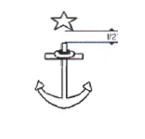

(2) For Summer White and Service Khaki uniforms, a single star shall be worn on the left breast pocket flap centered ¼ inch below the top of the pocket.

2. Service Assignment Insignia

a. Description. Gold colored metal miniature warfare specialty distinguishing device (lapel sized).

b. Provision for Wear. Midshipmen First Class are authorized to wear the device representing their service assignment from the date of their service assignment through Commissioning.
c. Manner of Wear. Authorized for wear on Summer White and Service Khaki uniforms.
(1) The pin will be worn centered on the left breast pocket flap ¼ inch below the top of the pocket.

(2) If worn concurrently with the Distinguished Midshipman Star, both insignia shall be worn centered in the position indicated above in a horizontal line with each device ¾ inch apart.

APPENDIX A
MILITARY CHAIN OF COMMAND

Article
A01. Military Chain of Command
A02. Other VIPs
A03. Midshipman Battalion

A01. MILITARY CHAIN OF COMMAND

President of the United States

Secretary of Defense

Secretary of the Navy

Chief of Naval Operations

Commandant of the Marine Corps

Chief of Naval Education and Training

Commander, Naval Service Training Command

Commanding Officer, NROTC Unit, North Carolina Piedmont Region

Battalion Commander, Duke/NC State/UNC

Company Commander/Platoon Commander, Duke/NC State/UNC

A02. POSITION OF AUTHORITY

Vice President of the United States

Chairman of the Joint Chiefs of Staff

Vice Chairman of the Joint Chiefs of Staff

Vice Chief of Naval Operations

Assistant Commandant of the Marine Corps

Master Chief Petty Officer of the Navy

Sergeant Major of the Marine Corps

Executive Officer, NROTC Unit, North Carolina Piedmont Region

Marine Officer Instructor, NROTC Unit, North Carolina Piedmont Region

Lieutenant Advisor, Duke/NC State/UNC
Assistant Marine Officer Instructor, Duke/NC State/UNC

Student Chain of Command

A03. STUDENT BATTALION

1. Each student Battalion within the consortium shall maintain their own Battalion chain of command according to the size and specific needs of their Battalion.

APPENDIX B
PHYSICAL TRAINING AND BODY COMPOSITION STANDARDS

Article
B01. Male Navy PRT Standards
B02. Female Navy PRT Standards
B05. Male Marine PFT Standards
B06. Female Marine PFT Standards
B07. Male and Female Marine CFT Standards
B08. Navy Body Composition Assessment Information
B09. Marine Corps Body Composition Assessment Information

B01. MALE NAVY PRT STANDARDS

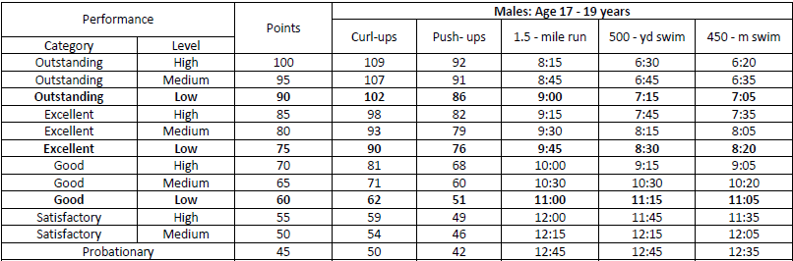
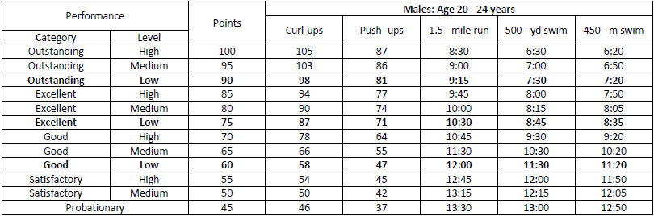
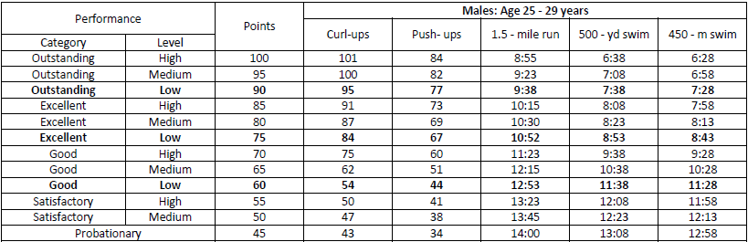
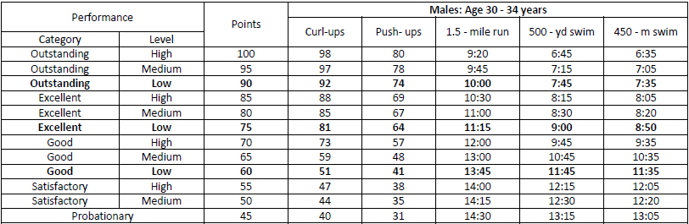

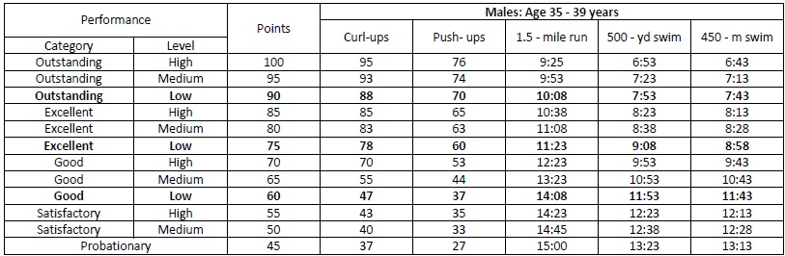
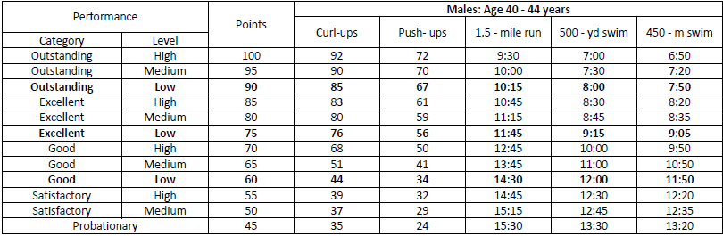

B02. FEMALE NAVY PRT STANDARDS

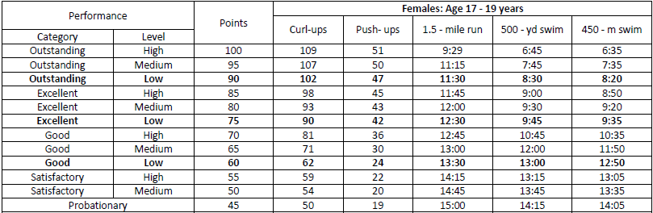
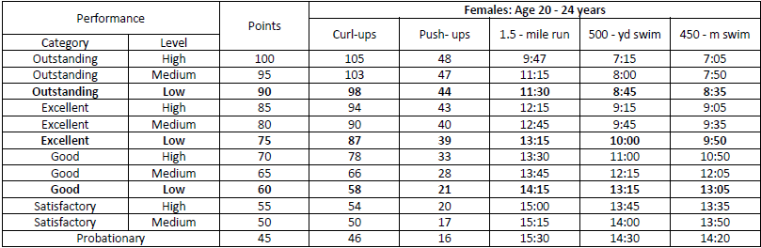
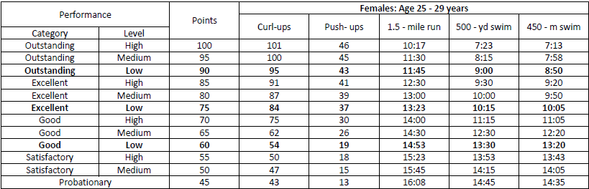
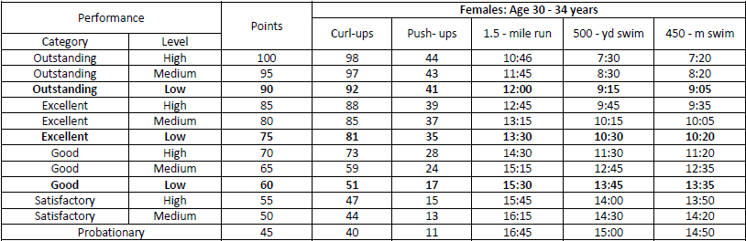
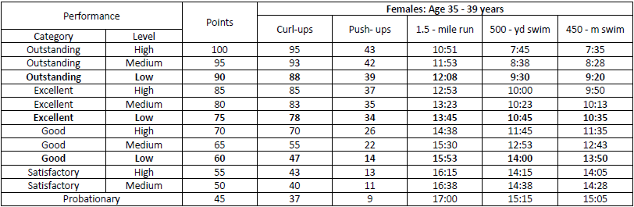
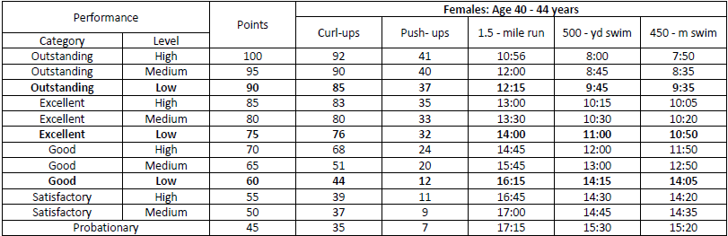

B03. MALE MARINE PFT STANDARDS

For Marine PFT Standards, refer to Marine Corps Bulletin 6100, MARINE CORPS PHYSICAL FITNESS AND COMBAT FITNESS TESTS.

Required Minimum Classification Scores

AGE | UNSAT | 3/C |  | 2/C | * | 1/C
17-26 | 0-134 | 135 |  | 175 ** |  | 225
27-39 | 0-109 | 110 |  | 150 |  | 200

*The minimum required to attend Officer Candidate School is 250.

Required Minimum Acceptable Performance

AGE | PULLUPS | SITUPS | RUN | PASSING SCORE
17-26 | 3 | 50 | 28 MIN | 135
27-39 | 3 | 45 | 29 MIN | 110

B04. MARINE FEMALE PFT STANDARDS

For Marine PFT Standards, refer to Marine Corps Bulletin 6100, MARINE CORPS PHYSICAL FITNESS AND COMBAT FITNESS TESTS.

Required Minimum Classification Scores

AGE | UNSAT | 3/C |  | 2/C | * | 1/C
17-26 | 0-134 | 135 |  | 175 |  | 225
27-39 | 0-109 | 110 |  | 150 |  | 200

*The minimum required to attend Officer Candidate School is 250.

Required Minimum Acceptable Performance

AGE | FAH | SITUPS | RUN | PASSING SCORE
17-26 | 15 SEC | 50 | 31 MIN | 135
27-39 | 15 SEC | 45 | 32 MIN | 110

B05. MALE AND FEMALE CFT STANDARDS

For Marine CFT Standards, refer to Marine Corps Bulletin 6100, MARINE CORPS PHYSICAL FITNESS AND COMBAT FITNESS TESTS.

B06. NAVY BODY COMPOSITION ASSESSMENT INFORMATION

1. The Navy's Body Composition Assessment (BCA) is based on the maximum weight for height screening and body fat percentage estimation. The body fat estimation is based on circumference measurements. The Navy uses weight charts for initial screening. Only midshipmen not meeting the Navy weight standard for their height will be measured for body fat percentage.

2. Due to muscle mass and other factors, exceeding the weight indicated on the chart doesn't necessarily mean you are considered overweight. It means that the Navy needs to perform a body fat measurement to determine if you fall within the prescribed Navy body fat standards. The Navy's Body Fat Standards include the following:

a. Graduated Body Composition Assessment Standards

Gender |  | Age (years)
 | 17-21 |  | 22-29 | 30-39 | 40+
Male | 22% |  | 23% | 24% | 26%
Female | 33% |  | 34% | 35% | 36%

b. Maximum Weight for Height Standards

 | Male | Female
Height( Inches) | Navy Weight Standard (pounds) | Navy Weight Standard (pounds)
58 | 131 | 131
59 | 136 | 136
60 | 141 | 141
61 | 145 | 145
62 | 150 | 149
63 | 155 | 152
64 | 160 | 156
65 | 165 | 160
66 | 170 | 163
67 | 175 | 167
68 | 181 | 170
69 | 186 | 174
70 | 191 | 177
71 | 196 | 181
72 | 201 | 185
73 | 206 | 189
74 | 211 | 194
75 | 216 | 200
76 | 221 | 205
77 | 226 | 211
78 | 231 | 216
B07. MARINE CORPS BODY COMPOSITION ASSESSMENT INFORMATION

1. Marine Options must comply with established body composition standards and present a suitable military appearance, regardless of age, grade, gender, per Marine Corps Order 6110.3A, Marine Corps Body Composition and Military Appearance Program.

APPENDIX C
US Navy Uniform Regulations (NAVPERS 15665i), Chapter 6, Section 1

Article
C01. General
C02. Cap Insignia
C03. Sleeve Class Insignia
C04. Sleeve Rank Insignia
C05. Shoulder Boards
C06. Coat Collar Anchor Insignia and Coat Collar Star Insignia
C07. Shirt Collar Insignia

C01. GENERAL

1. This chapter applies to the insignia worn by personnel in officer accession programs.

2. The Superintendent, U. S. Naval Academy, is authorized to prescribe insignia for the use of midshipmen within the limits of the U.S. Naval Academy, in ceremonies or activities held outside the limits of the Academy, for detachments of midshipmen operating with other naval personnel, or in connection with ceremonies or activities held outside the limits of the Academy in which midshipman detachments participate.

3. Insignia worn by NROTC midshipmen and other officer candidate program personnel, conform to that prescribed for U.S. Naval Academy Midshipmen. NROTC Marine option midshipmen wear gold, enlisted Marine Corps emblems in place of the anchor insignia.

4. Upon commissioning, all midshipmen uniforms, regardless of issue source, shall comply with uniform guidelines established for commissioned officers.

C02. CAP INSIGNIA

1. Combination Cap. Insignia on combination caps consist of a cap device, chin strap and retaining buttons.

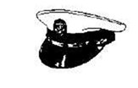

a. Cap Device. The insignia is a gold, fouled anchor. The length of the anchor, including the fouling, measures 1-13/16 inches; 1-1/8 inches wide at flukes; 1-1/8 inches wide at the stock with other dimensions proportionate. Attach the device to the mount of the cap band, with the unfouled arm of the stock facing the wearer's right.


b. Chin Strap. The chin strap is 3/8 inch wide, faced with gold lace and fastened at each end by a 22 1/2 line, Navy eagle, gilt button.

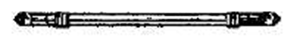

2. Garrison Cap

a. Insignia is a gold metal fouled anchor 1-1/16 inches in length with other dimensions proportion- ate. The unfouled arm of the stock faces front. Pin it to the left side of the cap in an upright position with the center 2 inches from the front seam and 1-1/2 inches above bottom edge.

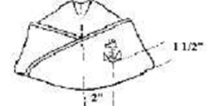

C03. SLEEVE CLASS INSIGNIA

1. USNA. Consists of stripes worn on the sleeves of blue coats to indicate class.

a. Midshipmen, First Class (1/C). Wear one stripe of yellow braid, 1/8 inch wide, around each sleeve, placing the lower edge of the stripe 2 inches from and parallel to the edge of the cuff.

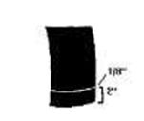

b. Midshipmen, Second Class (2/C). Wear two stripes of yellow braid, 1/8 inch wide on the left sleeve only. Place the stripes diagonally on the sleeve between the rear and front seams with the lowest stripes 4-1/2 inches above the edge of the cuff at the front seam and 11 inches at the rear seam.

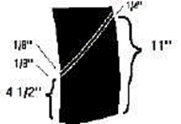
c. Midshipmen, Third Class (3/C). The insignia is same as described for Midshipmen, 2/C, but only the lower stripe is worn.

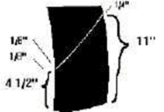

d. Midshipmen, Fourth Class (4/C). Wear no sleeve stripes.



2. NROTC. Consists of horizontal stripes worn on the left sleeve of blue coat to indicate class. Stripes are made of gold nylon braid 1-1/2 inches long and 1/8 inch wide with 1/4 inch spacing between stripes. They are centered midway between shoulder and elbow.

a. Midshipmen, First Class (1/C). Wear three stripes.



b. Midshipmen, Second Class (2/C). Wear two stripes.



c. Midshipmen, Third Class (3/C). Wear one stripe.



d. Midshipmen, Fourth Class (4/C). Wear no stripes.

C04. SLEEVE RANK INSIGNIA

1. Midshipmen Officers. Wear stripes of gold nylon braid and a gold star on both sleeves of the blue coat. Stripes measure 1-1/2 inches long and 1/8 inch wide, centered on the outer side of the sleeve with lower stripe 2 inches above and parallel to the edge of the cuff, the stripes to be 1/4 inch apart. Center a gold embroidered, symmetrical five pointed star, 1 inch across, above the stripes. One ray of the star points down, and the point is 3/4 inch above the upper stripe.

a. Captain. Six stripes.



b. Commander. Five stripes.



c. Lieutenant Commander. Four stripes.

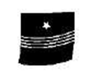

d. Lieutenant. Three stripes.

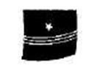

e. Lieutenant Junior Grade. Two stripes.



f. Ensign. One stripe.



2. Midshipmen Petty Officers. Wear insignia on the blue coat identical to that worn by U.S. Naval Academy Midshipmen Petty Officers except the highest NROTC Petty Officer rank is Battalion Chief Petty Officer.

C05. SHOULDER BOARDS

1. General. There are two types of shoulder boards, one indicating class and one indicating rank. Both measure either 5-1/2 inches (men), or 4-1/2 inches (women) long and 1-3/4 inches wide with outer end squared and inner end terminating in a symmetrical peak made of dark blue cloth. They are rigid and attached on the shoulder at the inner end by a 22 1/2-line Navy eagle, gilt button snap fastener. They are worn on the coat of Full Dress White uniforms, the blue overcoat, reefer, Dinner Dress jacket and on the white tropical shirt. NROTC Marine midshipmen replace the anchor insignia on the shoulder boards with the gold, enlisted Marine Corps emblem.

2. Class Shoulder Boards. The insignia for shoulder boards consists of a metal fouled anchor alone or in combination with stripes, indicating the wearer's class.

a. Midshipman, First Class (1/C). Center a gold metal fouled anchor, 1-1/16 inches in length, with other dimensions proportionate, on the shoulder board with the crown 2 inches from the squared end and the unfouled arm of the stock to the front. Place one yellow stripe, 1/8 inch wide, with the outer edge 5/8 inch from and parallel to the squared end of the shoulder board (right and left).



b. Midshipman, Second Class (2/C). Same as prescribed for Midshipman, First Class, except that there are two yellow stripes, 1/8 inch wide, placed diagonally across the shoulder board. The front edge of the bottom stripe is 5/8 inch and the rear edge of the bottom stripe is 1-5/8 inches from the squared end of the board. The stripes are parallel and spaced 1/8 inch apart; lower end to the front (right and left).



c. Midshipman, Third Class (3/C). Same as prescribed for Midshipman, Second Class, but the upper stripe is omitted (right and left).



d. Midshipman, Fourth Class (4/C). Same as prescribed for Midshipman, First Class, but the stripe is omitted (right and left). For women the anchor crown is 1-1/4 inches from the squared end.



3. Rank Shoulder Marks. The insignia worn on shoulder boards consists of a star, in combination with stripe(s), to indicate the wearer's rank.

a. Captain. Wear six yellow stripes, 1/8 inch wide. Place the lowest stripe 5/8 inch from and parallel to the squared end of the mark. Space other stripes 1/4 inch apart. Center a gold plated metal, five point star, 1/2 inch across on the shoulder board, with one point facing toward and 1/2 inch from the upper stripe.



b. Commander. Same as prescribed for Captain, except there are five stripes.



c. Lieutenant Commander. Same as prescribed for Captain, except there are four stripes.



d. Lieutenant. Same as prescribed for Captain, except there are three stripes.



e. Lieutenant Junior Grade. Same as prescribed for Captain, except there are two stripes.



f. Ensign. Same as prescribed for Captain, except that there is one stripe.



C06. COAT COLLAR ANCHOR INSIGNIA AND COAT COLLAR STAR INSIGNIA

1. General. Coat collar insignia consists of plain gold anchors indicating midshipman status and gold stars indicating Distinguished Midshipman worn on the collars of the blue coats.

2. Service Dress Blue Coat

a. Anchor Insignia. A plain gold anchor 17/16 inch long, the stock, 3/4 inch wide, and the flukes 1-1/17 inches wide. The stock inclines at an angle of 8 degrees from the horizontal (right and left). Pin it on each collar tip of the coat so the anchor's crown is 1/2 inch above the notch of the lapel (males), 1 inch from the bottom and midway between the two sides (females), and the center line of the shank is parallel to and approximately 3/4 inch from the collar's outer edge. The lower end of the stock is outboard and the stock approximately horizontal.

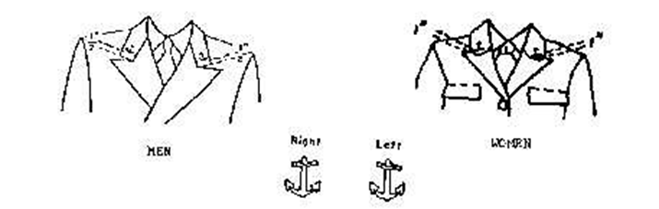

b. Star Insignia. Same as described above for Service Dress Blue coats and worn on each side of the collar in the same relative position.

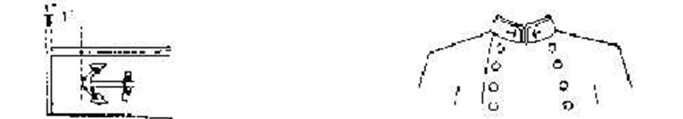
C07. SHIRT COLLAR INSIGNIA

1. General. Shirt collar insignia consists of gold fouled anchor, eagle, and bar worn on the collar tips of blue and khaki shirts, to indicate the wearer's class and/or rank.

2. Insignia Indicating Class and Petty Officer Rank

a. Anchor Insignia. A gold metal fouled anchor, 5/8 inch (right and left).

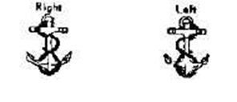

b. Eagle-Anchor Insignia. Consists of a spread eagle on gold metal fouled anchor. The device is 11/16 inch (right and left).



c. Manner of Wear. Pin the anchor or eagle- anchor insignia to the collar in a vertical position with the center of the insignia approximately 1 inch from the front edge and 1 inch below the upper edge of the collar. The anchor's stock is parallel to the upper edge of the collar and the unfouled arm of the stock faces front.

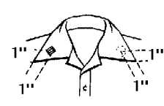

(1) Midshipmen, First Class (1/C) of other than Officer Rank. Wear the eagle-anchor insignia on both collar points. Note: Picture does not indicuate insignia location, only an example of which insignia to wear.

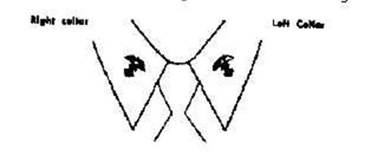

(2) Midshipmen, Second Class (2/C) of other than
Officer Rank. Wear the anchor insignia on both collar points. Note: Picture does not indicuate insignia location, only an example of which insignia to wear.

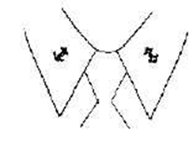

(3) Midshipmen, Third Class (2/C). Wear the anchor insignia on the right collar point only. Note: Picture does not indicuate insignia location, only an example of which insignia to wear.

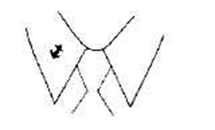

(4) Midshipmen, Fourth Class (4/C). Wear no insignia on the collar.

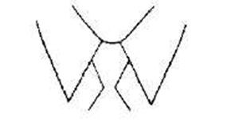

3. Insignia Indicating Class and Petty Officer Rank. (Other Officer Candidate Programs). It is the same as the shirt collar anchor insignia prescribed for U.S. Naval Academy and Naval Reserve Officers Training Corps Midshipmen. This insignia is worn by all officer candidates, on collar points of the khaki and blue shirts in a horizontal position with the crown to the front. The unfouled arm of the stock points up. Officer candidates wear:

Fourth Classmen: No insignia.
Third Classmen: One anchor, right collar.
Second Classmen: One anchor, on each collar.
First Classmen: One eagle-anchor on each collar.

4. Insignia Indicating Midshipman and Officer Candidate Rank. Consists of gold metal bars, on the collar tips of blue and khaki shirts to indicate the wearer's rank. On closed collar shirts, pin this insignia on the collar so that the center of the first bar is approximately 1 inch from the front edge and 1 inch below the upper edge of the collar. The upper edge of bars is parallel to upper edge of collar. On open collar shirts, all midshipmen, except Captains, center insignia one inch from the front and lower edges of the collar and position it with the vertical axis of the insignia along an imaginary line bisecting the angle of the collar point. Captains wear insignia one quarter inch from the lower and outside edges of the collar and position it with the vertical axis of the insignia along an imaginary line bisecting the angle of the collar point.

a. Captain. Wear six parallel bars, each 3/4 inch wide, and spaced 1/8 inch apart, connected by a thin strip of wire or metal.

b. Commander. Wear five parallel bars each 3/4 inch wide, and spaced 1/8 inch apart and connected by a thin strip of wire or metal.

c. Lieutenant Commander. Wear four parallel bars each 3/4 inch wide, and spaced 1/8 inch apart and connected by a thin strip of wire or metal.

d. Lieutenant. Wear three parallel bars each 3/4 inch wide, and spaced 1/8 inch apart and connected by a thin strip of wire or metal.

e. Lieutenant Junior Grade. Wear two parallel bars each 3/4 inch wide, and spaced 1/8 inch apart and connected by a thin strip of wire or metal.

f. Ensign. Wear one bar.

APPENDIX D
Lab Rating Form

SAMPLE Student Lab Feedback & Evaluation Survey

Name:

Date of Lab:

Company and Platoon:

Conflict (circle):

Early Late None

1. List the lab activities you were able to attend (do not include events missed due to conflict):

2. From 1 to 10, with 1 being Not Effective and 10 being Very Effective, how effective was the training?

3. What was one aspect of each event that went well?

4. What was one aspect of each event that did not go well and how could it be fixed?

5. What is one improvement on each event that could be made?

6. What was your main take away from this lab?

7. Other remarks?

APPENDIX E
Student Evaluation Format
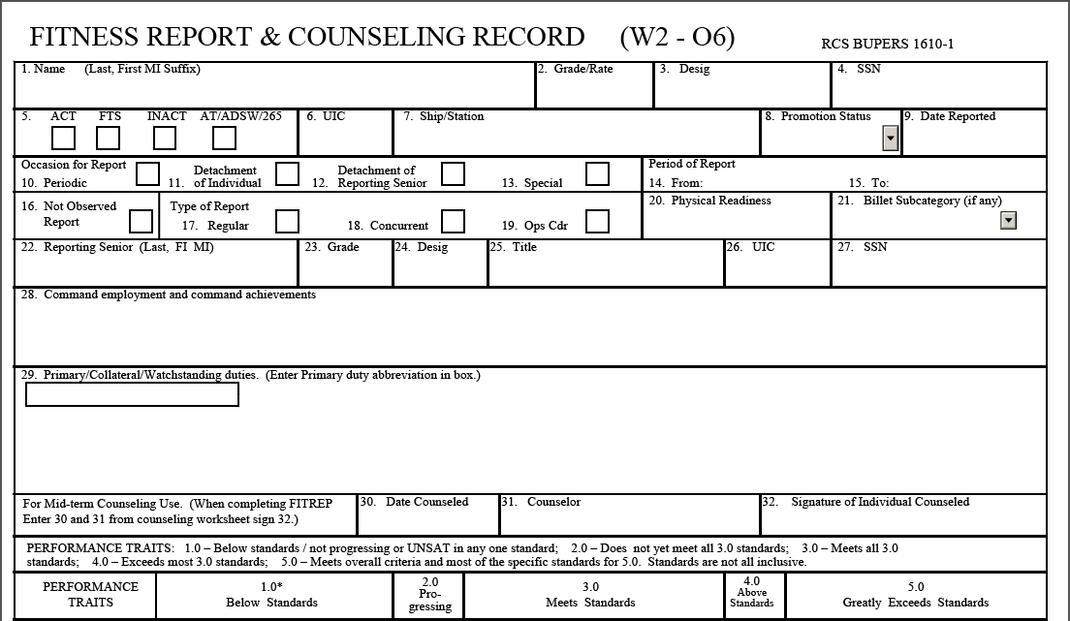
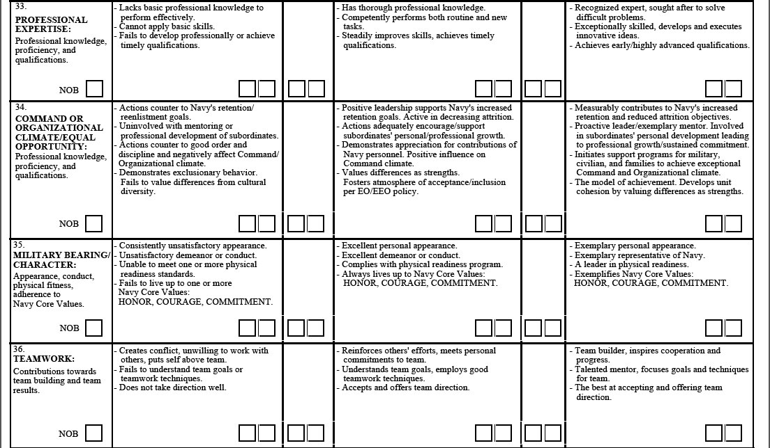
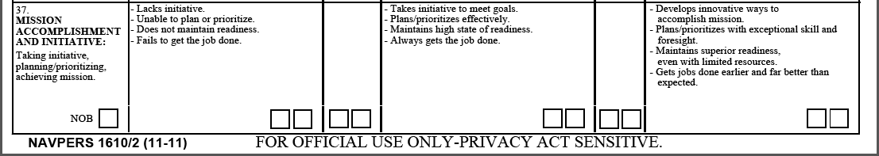

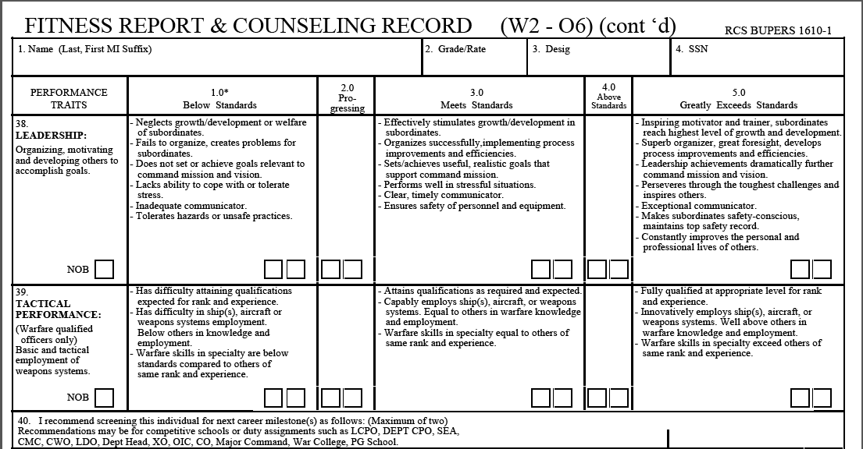
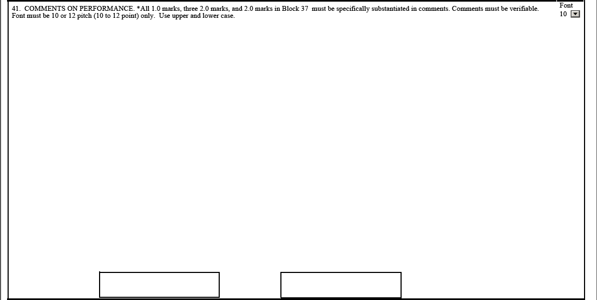
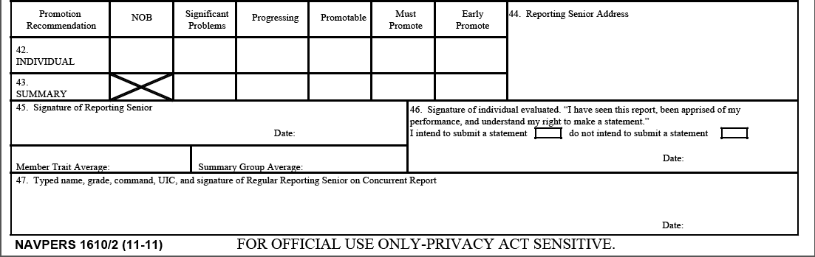
APPENDIX F
Plan of the Week Template

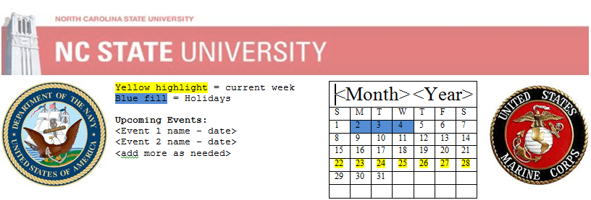
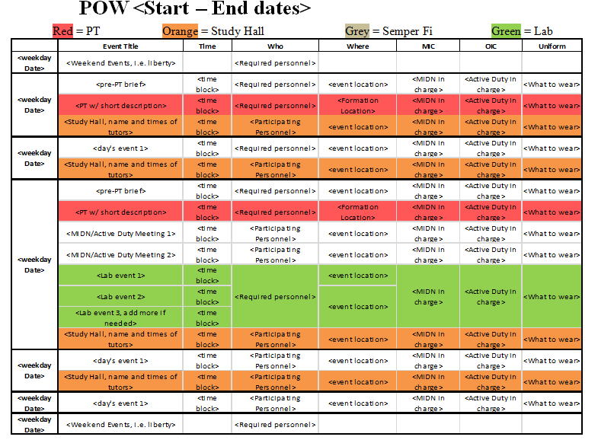

APPENDIX G
Turnover Checklist

TURNOVER CHECKLIST

_____ 1. Outgoing update and give turnover binder to incoming.

_____ 2. Outgoing go over turnover binder with incoming.

_____ 3. Have incoming sit in on a meeting with the staff mentor for the position.

_____ 4. Have incoming sit in on a staff meeting.

_____ 5. Go over schedule (daily, weekly, monthly, quarterly).

_____ 6. Go over how to best utilize those who report to the position.

_____ 7. Go over joint tasks with other positions.

_____ 8. Establish deadlines for immediate and major projects/tasks.

_____ 9. Go over how to brief in staff meetings and what information
should be included.

_____ 10. If not included in turnover binder, outgoing provide examples to incoming of completed paperwork used throughout the semester.

_____ 11. Go over expectations as outlined in the Student Regulations.

_____ 12. Pass to incoming all relevant contact information.

_____ 13. If not a part of the turnover binder, transfer ownership of relevant Google Drive files to incoming.

_____ 14. Transfer administrative log-in privileges for any applicable websites or accounts to incoming.

_____ 15. Go over counseling procedures for subordinates.

_____ 16. Turn over relevant insignia.

Incoming Officer Signature: __________________________________________

Outgoing Officer Signature: __________________________________________

Staff Mentor Signature: _____________________________________________
APPENDIX H
Striper Request Template

Striper Selection and Dream Sheet
Student Information
Rank and Full Name | «Rank»«First_Name»«Last_Name»
Major | «Major_»
GPA | «GPA»
Credit Hours During Desired Billet Period | «Credit_Hours_During_Desired_Billet_Perio»
Anticipated Graduation Date | «Anticipated_Graduation_Date_for_the_day»
PFA/PFT Score | «PRTPFT_Score_use_incoming_PRT_score»
Mentor/Protégé | «MentorProetege»
Previous Billets Held
4/C Fall | «Billet_Held_During_4C_Fall»
4/C Spring | «Billet_Held_During_4C_Spring_»
3/C Fall | «Billet_Held_During_3C_Fall_»
3/C Spring | «Billet_Held_During_3C_Spring_»
2/C Fall | «Billet_Held_During_2C_Fall»
2/C Spring | «Billet_Held_During_2C_Spring_»
1/C Fall | «Billet_Held_During_1C_Fall»
1/C Spring | «Billet_Held_During_1C_Spring_»
Top Choice Billets for Next Semester
1st Choice | «What_Billet_Would_you_like_to_hold_durin»
2nd Choice | «What_is_your_2nd_choice_billet_»
3rd Choice | «What_is_your_3rd_choice_billet_»
In you first choice billet for next semester, how will you impact the Battalion in this function?
How will this Billet help you to become a more effective Naval Officer?
Advisor Comments

APPENDIX I
Example Combined Staff Battle Rhythm

NCPR (NCSU) COMBINED BATTLE RHYTHM

EVENT | DAY | NLT | LOCATION | WHO
Quarter Deck Society Financial Audit | Monthly | 25th | RM186D | LT Yaeger, OC Berlin
Annual Training Review | Monthly | 25th | XO’s Office | XO, LT Meek, AMOI
USMC Status Report | Semesterly |  | Email | AMOI to MCRC
OPMIS Update | Semesterly |  | RM186 | All
EVENT | DAY | NLT | LOCATION | WHO
Battalion PT | Monday | 0600 | NC State | All
Battalion Supply Hours | Monday | 1130 | Supply Cage | MIDN Klecker, As required (1130-1230)
Semper Fi Lab | Monday | 1500 | RM122 | MOI, AMOI, Semper Fi
Semper Fi PT | Tuesday | 0530 | RM122 | MOI, AMOI, Semper Fi, LT Watson
Check CO’s Calendar | Tuesday | 0900 | Office | NROTC Staff
Duke Staff Meeting Notes Review | Tuesday | 1330 | NCPR | XO, NCSU, DUKE, UNC
Company PT | Wednesday | 0600 | NC State | All
NROTC Weekly Staff Huddle | Wednesday | 0930 | Office | NROTC Staff
Commander’s Call | Wednesday | 0830 | CO’s Office | CO, MIDN Noyes
CFL Sync Meeting | Wednesday | 1000 | RM126B | LT Showanes, AMOI, MIDN Maz
Semper Fi Sync Meeting | Wednesday | 1100 | RM186E | AMOI, MIDN Van Der Werff
Staff Meeting | Wednesday | 1300 | RM122 | NROTC Staff
XO’s Call | Wednesday | 1745 | XO’s Office | XO, MIDN Wallace
Drill | Thursday | 0600 | South Lobby | AMOI, Drill Commander
Check CO’s Calendar | Thursday | 0900 | Office | NROTC Staff
Plan of the Submission to Staff | Thursday | 1600 | Email | MIDN Howard TO MOI, LT YAEGER, AMOI
MIDN Staff Slides to MIDN XO | Thursday | 1700 | Google Drive | MIDN Staff & Company Commanders
Senior Enlisted Meeting | Thursday | 0700 | RM186E | AMOI, SgtMaj, 1stSgts, PltSgts
FEP / Make-up PRT | Friday | 0600 | NC State | As required
Make-up Lab | Friday | 0600 | RM122 | As required
Student Staff Meeting | Friday | 0745 | RM122 | MOI, AMOI, MIDN Staff
Ops Sync | Friday | 1400 | RM186F | LT Yaeger, MIDN Howard
Color Guard | Friday | 1500 | Wardroom | AMOI, Guard
APPENDIX J
Example Plan of Action and Milestones (POA&M)

This provides an example and is not intended to reflect any particular event. The intent of a Plan of Actions and Milestones is to clearly document all necessary steps in planning an event and ensure timely completion of those steps. An actual date should be assigned, a description of the task given, and a responsible individual assigned for completion of that task. Be as detailed as possible so that anyone who reviews your plan will have a clear understanding of exactly what should be happening. This will allow reviewers to provide guidance based on their experiences.

No. | Completion Date | EVENT NARRATIVE | ACTION
 | Date | Provide CO and XO with sample POA&M and discuss other concerns. | Those Responsible
 | Date | Provide Guest List and their respective address. | Those Responsible
 | Date | Confirm date to discuss ceremony script. | Those Responsible
 | Date | Outline monetary funding. | Those Responsible
 | Date | Discuss and finalize awards. | Those Responsible
 | Date | Determine invitation designs. | Those Responsible
 | Date | Resolve all logistical concerns for VIP’s. Create speaker’s biography, and photo for program book. | Those Responsible
 | Date | Decide on Reception options. | Those Responsible
 | Date | Finalize logistical concerns (parking, seating, sound system, and all other aspects). | Those Responsible

APPENDIX K
Letter of Instruction Template
SSIC
Code
date
MEMORANDUM

From: person sending
To: person receiving
Via: anyone that needs to see it first

Subj: ALL CAPS, SUBJECT OF THE DOCUMENT

Ref: (1) First Reference Document
(2) Second Reference Document
(3) Etc.

Encl: (1) First Enclosure
(2) Second Enclosure
(3) Etc.

1. Situation. What is the reason for this LOI? For example: The first-class midshipmen will be commissioned on the afternoon of Saturday, XX May 20XX.

2. Mission. What is the objective? For example: To conduct a successful commissioning ceremony and reception.

3. Execution

a. Commander’s Intent. What is your CO’s guidance and what does he/she want out of the event? For example: The purpose of this event is to commission the first-class as new Ensigns and Second Lieutenants in the United States Navy and United States Marine Corps. It will also provide an opportunity for the Battalion and its guests to celebrate with the newly commissioned Officers.

b. Concept of Operations. In your mind, how will the event be conducted? For example: The commissioning ceremony and subsequent events will be executed in six distinct stages.

(1) Stage 0 - Rehearsal. On XX and XX May from 1000-1300, all commissionees, the OIC, SNCOIC, and MIC will meet to practice the commissioning ceremony and make final preparations.

(2) Stage I - Setup. The University will open the building at 0800 to facilitate setup. Non-commissioning midshipmen will meet at 1130 to move the required gear. The midshipmen will then setup and decorate the room for the commissioning portion of the ceremony. Food items that need refrigeration will be put on ice in coolers.

(3) Stage II - Conduct Proper Ceremonies. At 1500, the commissioning ceremony will begin.

(a) Event I - Arrival. At 1445, all commissionees and their guests will arrive, ready to march in.

(b) Event II - Commissioning Ceremony. At 1500, the commissioning ceremony will take place as rehearsed.

(4) Stage III – Plaque Presentations and First Salutes. After the commissioning ceremony guests and necessary personnel will present commissioning plaques and conduct the ceremonial first salutes. The newly commissioned officers will sign the Oath of Office. The working party midshipmen may witness the first salutes.

(5) Stage IV - Reception. At 1630, the reception will begin.

(6) Stage V - Cleanup and Breakdown. At 1715, the working detail will remove all materials and return the area to its original state.

4. Uniform of the Day

a. U.S. Navy Participants. Appropriate Uniform.

b. U.S. Marine Corps Participants. Appropriate equivalent.

c. U.S. Navy Guests. Appropriate equivalent.

d. U.S. Marine Corps Guests. Appropriate equivalent.

e. Midshipmen. Appropriate equivalent.

f. Commissionees. Appropriate Uniform.

g. Civilian Guests. Appropriate equivalent.

5. Command and Signals. Who is in charge of the event? What is the chain of command for the event? How will you contact those involved? For example:

a. Signal. All attendees will be reminded of the function via their school coordinator a month prior by email as well as one week before. A final reminder will be in the lab the week of the event in person.

b. Command. Midshipmen, Officer Candidates, and Marines will be under the control of the Chain of Command.

(1) Officer in Charge. Name/Phone/Email

(2) Non-Commissioned Officer in Charge. Name/Phone/Email

(3) Midshipman in Charge. Name/Phone/Email
(1st space)
(2nd space)
(3rd space)
I. W. ROTETHIS
Sign above your name, 3 spaces between last line and name

Other sections may be added as appropriate. For instance, if a consortium event is planned, directions should be added. Examples are below:

1. Coordinating Instructions: May be required if you are planning a consortium event. What should the other schools / people involved be doing?

(1) North Carolina State University MIC

(a) Ensure every member of Battalion is in proper uniform.
(b) Submit accurate event roster to Midshipman Smith.
(c) Assign personnel to event duties.
- 10 participants to set up and tear down, respectively
(d) Bring all assigned equipment to event location.

(2) Duke University MIC

(a) Ensure every member of Battalion is in proper uniform.
(b) Submit accurate event roster to MIDN Smith.
(c) Assign personnel to event duties.
- 6 participants to set up and tear down, respectively
(d) Bring all assigned equipment to event location.

(3) UNC-CH MIC

(a) Enforce deadlines given to other MICs.
(b) Reserve and approve condition of event location

2. Inclement Weather Plan. If the event is outdoors, can it occur in inclement weather? If not, what is your plan for poor weather?

3. Safety. If the event involves physical activity or has potential for injury, what extra precautions do you need to take so that the event can be conducted in a safe manner?

4. Schedule. While this may be included in the concept of operations (as above), it can be broken out into a separate section for ease of reading.

0830-0930: Set-up
0900-0930: Arrival of Battalions
0940: Formation of Battalions
0940-0950: CO and/or XO comments
0950-1000: Event and Safety Brief
1000-1010: Individual warm up
1010-1300: Games/Events (enclosure 2)
1100-1300: Chow
1300-1310: Awards, conclusion
1310-1410: Tear Down, Clean-Up

5. Administration and Logistics. This section can include multiple subsections, tailored to the event. How will you ensure you have all the items you need for the event? How will you get to the event?

a. Supply. Each school’s required equipment will be pre-staged the day before the event. Assigned MIDN will ensure that they have all keys needed for access and transportation the day before.

b. Transportation. Midshipmen, Officer Candidates, and Marines from all schools will ride with family or arrange transportation. See attached map and routes from UNC, Duke, and NCSU ROTC buildings (Enclosure 3).

I. M. SAILOR

APPENDIX L
Special Request/Authorization Form (NAVPERS 1336/3)
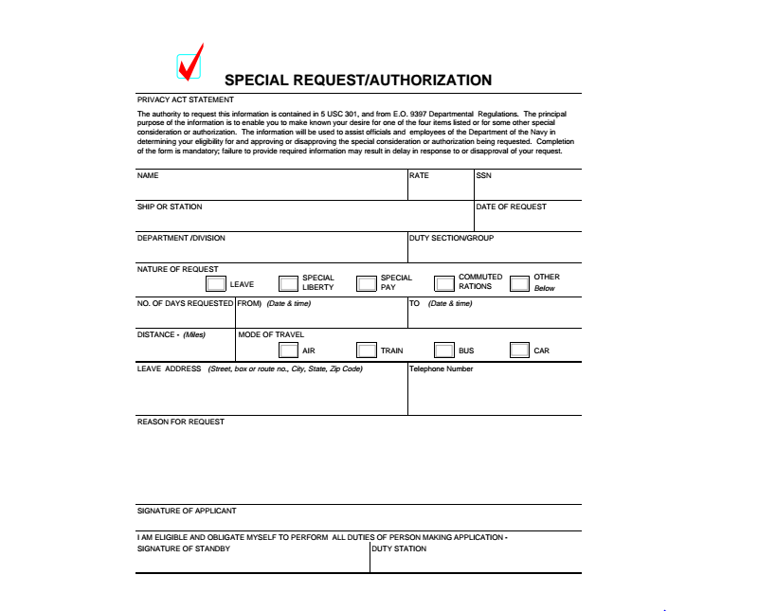
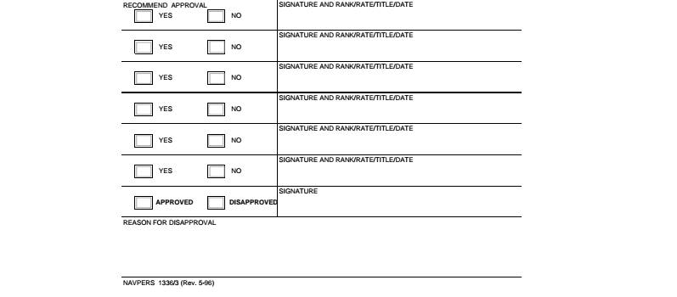

DEPARTMENT OF THE NAVY
NAVAL SERVICE TRAINING COMMAND
2601A PAUL JONES STREET
GREAT LAKES, ILLINOIS 60088-2845

NSTCINST 5000.1E
27 Jun 16

COMMANDER
NAVAL SERVICE TRAINING COMMAND

POLICY STATEMENT REGARDING EQUAL OPPORTUNITY AND DIVERSITY

1. Each Naval Service Training Command (NSTC) civilian and military member deserves to work in an environment that allows them to perform to their maximum ability. Merit, ability, performance, and potential must be the only factors that affect an individual’s professional and personal development. Additionally, each person deserves to work in an environment that allows them to live and grow safely, peacefully, and without discrimination or harassment. Equal opportunity is a matter of sound leadership and human decency for all. Each and every member has an individual and collective responsibility to actively support an equal opportunity environment. Any violation of our equal opportunity environment will not be condoned or tolerated. Incidents of misconduct, discrimination, or harassment will be dealt with appropriately. Every effort will be made to access and retain a high-quality and an ethnically-diverse workforce of motivated and committed civilians and sailors who share our Navy’s core values of honor courage and commitment.

2. As Commander, I am personally committed to providing an equal opportunity environment and maintaining a diverse workforce. Additional information and resources regarding Department of the Navy equal opportunity and diversity policies and practices are available at:
http://www.donhr.navy.mil/
http://www.public.navy.mil/bupers-npc/support/

S. C. EVANS

Enclosure (1)
DEPARTMENT OF THE NAVY
NAVAL SERVICE TRAINING COMMAND
2601A PAUL JONES STREET
GREAT LAKES, ILLINOIS 60088-2845

NSTCINST 5000.1E
27 Jun 16

COMMANDER
NAVAL SERVICE TRAINING COMMAND

POLICY STATEMENT REGARDING SEXUAL HARASSMENT

1. Sexual harassment is unacceptable, inappropriate, and demeaning behavior that undermines the integrity of workplace relationships. It creates a hostile, offensive, and intimidating environment and will not be tolerated. Anyone in a supervisory position who uses or condones implicit or explicit sexual behavior to control, influence, or affect the career, pay, or position of another person is engaging in sexual harassment. Anyone who makes deliberate or repeated unwelcome verbal comments, gestures, or physical contact of a sexual nature is also engaging in sexual harassment. Corrective action will be taken swiftly, fairly, and effectively on those who violate these principles.

2. As Commander, I am personally committed to ensuring a safe, healthy, and supportive work environment. For more information on prevention of sexual harassment and complaint procedures, consult reference (a) and
http://www.public.navy.mil/donhr/eeo/programelements/Pages/DiscriminationComplaints.aspx

S. C. EVANS

Enclosure (2)
DEPARTMENT OF THE NAVY
NAVAL SERVICE TRAINING COMMAND
2601A PAUL JONES STREET
GREAT LAKES, ILLINOIS 60088-2845

NSTCINST 5000.1E
27 Jun 16

COMMANDER
NAVAL SERVICE TRAINING COMMAND

POLICY STATEMENT REGARDING HAZING

1. Hazing is an action in which a person is subjected to physical, mental, or verbal abuse. It is also a senseless and dangerous behavior that can subject a member to injury, ridicule, or personal degradation. Hazing is any situation where a person subjects another to cruel, meaningless conduct. Whether or not an individual consents or volunteers to participate is immaterial. In order to ensure human dignity for everyone and that the highest professional standards are upheld, hazing of any type will not be tolerated. Anyone having knowledge of a hazing incident must immediately inform their chain of command.

2. As Commander, I am committed to ensuring a safe environment throughout the domain. Training environments are especially susceptible to incidents of hazing. Hazing is contrary to our core values of honor, courage, and commitment. These core values are our guiding principles for treating everyone with dignity and respect. Hazing degrades and diminishes the ability of victims to perform in their assigned role, it destroys confidence and trust, and is destructive to unit cohesion. NAVADMIN 034/13 contains guidance for reporting incidents of hazing.

S. C. EVANS

Enclosure (3)
DEPARTMENT OF THE NAVY
NAVAL SERVICE TRAINING COMMAND
2601A PAUL JONES STREET
GREAT LAKES, ILLINOIS 60088-2845

NSTCINST 5000.1E
27 Jun 16

COMMANDER
NAVAL SERVICE TRAINING COMMAND

POLICY STATEMENT REGARDING SEXUAL ASSAULT

1. Sexual assault impacts our mission readiness and contradicts our Navy core values. Sexual assault involves inappropriate touching without mutual consent. Any allegation of sexual assault will be responded to appropriately through official investigation as well as support services for the victim. Active duty victims, including midshipmen on summer training, of sexual assault will be advised of the support services available and their reporting options - restricted and unrestricted. Midshipmen also have support services available through their campus crisis center. Unrestricted reports will be handled by the unit’s Sexual Assault Prevention and Response (SAPR) Point of Contact, unit chain of command, and NSTC SAPR Command Liaison. I will be briefed within 30 days on the status of the victim and any command impact.

2. As Commander, I am committed to preventing sexual assault throughout the domain. My “No Lions” approach, meaning the elimination of predatory behavior, will preemptively decrease the number of “blue on blue” allegations of sexual assault throughout the NSTC domain. Training, support, resources, and references regarding sexual assault prevention and response are available at http://www.public.navy.mil/BUPERS-NPC/SUPPORT/SAPR/Pages/default.aspx

S. C. EVANS

Enclosure (4)
DEPARTMENT OF THE NAVY
NAVAL SERVICE TRAINING COMMAND
2601A PAUL JONES STREET
GREAT LAKES, ILLINOIS 60088-2845

NSTCINST 5000.1E
27 Jun 16
COMMANDER
NAVAL SERVICE TRAINING COMMAND

POLICY STATEMENT REGARDING SAFETY

Naval Service Training Command has a vital interest in providing all personnel with a safe and healthful place of employment and to conduct business and training in the safest possible manner. The safety and health of all personnel is our utmost priority. The only acceptable level of safety and health performance is one that prevents all injuries, illnesses, and incidents. Safety and health are an integral part of our organization which cannot be separated from other business functions and must be shared equally by all employees within our domain. All personnel will be protected from, and all activities will be free of, discrimination, restraint, interference, coercion, or reprisal for participating in Naval Service Training Command’s safety and health program.

While we cannot reasonably remove all levels of risk inherent to our daily operations, we can strive to accept risks only when benefits outweigh costs. Unnecessary risks have no place in the workplace or our daily lives. This principle is applied by identifying potential hazards, assessing the risks associated with those hazards, and controlling risks to acceptable levels, consistent with the training or activity being performed. Reducing risk protects individual members in reducing fatalities, injuries and disease, loss of property, and ultimately promotes training readiness.

Every commanding officer, officer-in-charge, and supervisor is responsible and will be held accountable for ensuring that effective risk management principles are incorporated into the planning and execution of every training evolution and activity. They must also ensure that safe driving practices of government vehicles, in accordance with reference (j), are followed. Each member of Naval Service Training Command has a personal responsibility for effectively managing risks associated with their own activities, both on and off duty, and to safeguard themselves, their families and fellow shipmates from harm. These responsibilities cannot be delegated and must not be compromised.

I challenge each and every one of you to strive and make operational and non-operational/off-duty risk management a daily reality in Naval Service Training Command.

S. C. EVANS

Enclosure (5)

